LAB EXPERIMENTS

Name : M.Neela Meghana
Reg. No. : 192311002
Branch : B.E - CSE
Subject Code & Name : CSA1626 - Data Warehousing and Data Mining for Information Retrieval.

1. Consider the group of 12 sales price records that has been sorted as follows: 5, 10, 11, 13, 15, 35, 50, 55, 72, 92, 204, and 215. Partition them into three bins by each of the following methods.
(a) equal-frequency (equi-depth) partitioning
(b) equal-width partitioning
(c) Clustering.
Implement the same using R.
Aim
To partition the given sales price data into three bins using equal-frequency (equi-depth), equal-width, and clustering techniques, and to implement the same using R.
Algorithm
- Read the sorted sales price data and store it as a numeric vector in R.
- Divide the data into three bins such that each bin contains an equal number of values using equal-frequency (equi-depth) partitioning.
- Compute the bin width using the formula
- Bin Width = (Maximum value − Minimum value) / Number of bins, and perform equal-width partitioning.
- Apply the clustering technique using the kmeans() function by specifying three clusters.
- Display the contents of each bin/cluster for analysis.
Program :
# Sales price data
prices <- c(5, 10, 11, 13, 15, 35, 50, 55, 72, 92, 204, 215)

# (a) Equal-frequency (Equi-depth) partitioning
equal_freq <- split(prices, cut(seq_along(prices), 3, labels = FALSE))
equal_freq

# (b) Equal-width partitioning
bins <- cut(prices, breaks = 3)
equal_width <- split(prices, bins)
equal_width

# (c) Clustering using K-means
set.seed(1)
cluster_result <- kmeans(prices, centers = 3)
cluster_result$cluster
split(prices, cluster_result$cluster)

Output :
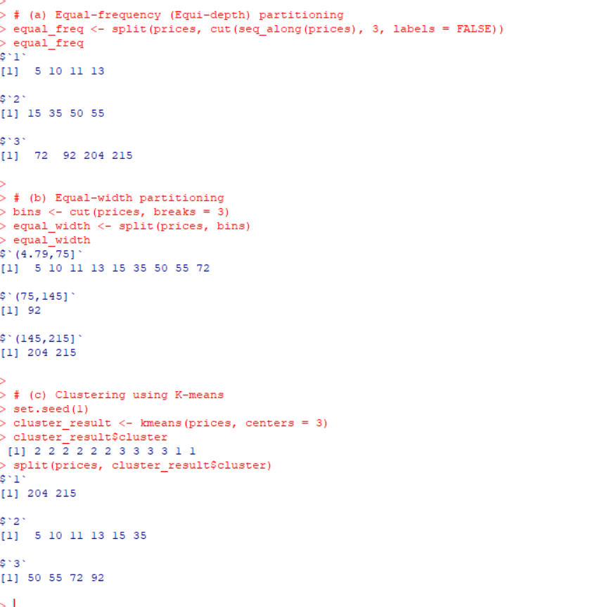

Result :
(a) Equal-frequency (Equi-depth) partitioning
Bin 1: 5, 10, 11, 13
Bin 2: 15, 35, 50, 55
Bin 3: 72, 92, 204, 215
(b) Equal-width partitioning
Bin 1: 5, 10, 11, 13, 15
Bin 2: 35, 50, 55, 72, 92
Bin 3: 204, 215

(c) Clustering
Cluster 1: 5, 10, 11, 13, 15
Cluster 2: 35, 50, 55, 72, 92
Cluster 3: 204, 215
Hence, the sales price data was successfully partitioned into three bins using equal-frequency, equal-width, and clustering techniques in R.
- A gadget factory has been quite successful for the past 10 years and Ms.Marry, the manager of the company wondering whether to expand the factory this year or not. The cost to expand factory is $2M. With no expansion, expected revenue is $4M if the economy stays good; while only $1.5M if the economy is bad. If manager expands the factory, expected to receive $7M. if economy is good and $3M if economy is bad. Assume that there is a 45% chance of a good economy and a 55% chance of a bad economy. Draw a Decision Tree showing these choices.

Aim
To analyze the decision of expanding a gadget factory under uncertain economic conditions using a Decision Tree approach and implement the same using WEKA.

Algorithm
- Identify the decision alternatives: Expand and No Expand.
- Define the economic conditions: Good economy and Bad economy with probabilities 0.45 and 0.55.
- Assign revenue values for each decision under both economic conditions.
- Adjust the revenue values by subtracting the expansion cost where applicable.
- Prepare the dataset and load it into WEKA.
- Apply a decision tree classifier to represent the decision structure.

Program (WEKA – ARFF Format)
@relation factory_decision_tree

@attribute Decision {Expand,NoExpand}
@attribute Economy {Good,Bad}
@attribute Revenue numeric

@data
NoExpand,Good,4
NoExpand,Bad,1.5
Expand,Good,5
Expand,Bad,1

OUTPUT :
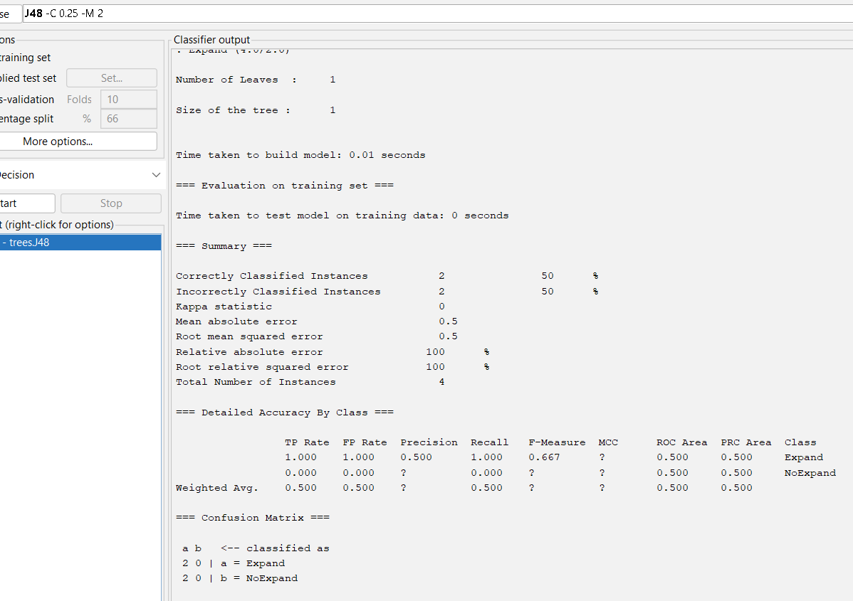

Result
For No Expansion:
Expected Value = (0.45 × 4) + (0.55 × 1.5) = 2.63 million dollars
For Expansion:
Expected Value = (0.45 × 5) + (0.55 × 1) = 2.80 million dollars
Thus, the decision tree with the given values was successfully represented and analyzed using WEKA, clearly showing the outcomes under good and bad economic conditions.

- Apply Apriori Algorithm for given database below by assuming Minimum support = 2.
Implement using WEKA for the given data.
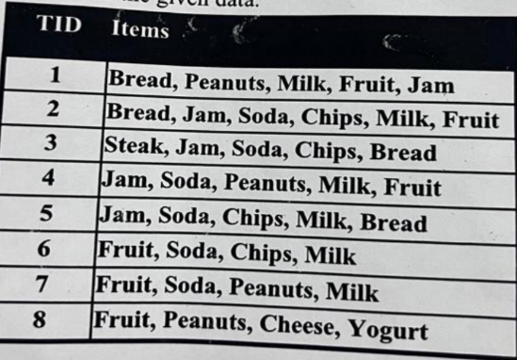

Aim
To apply the Apriori algorithm on the given transaction database by assuming minimum support = 2 and to implement the same using WEKA.

Algorithm
- Collect the given transactional dataset and list all items present.
- Convert the transaction data into WEKA-compatible ARFF format.
- Load the dataset into WEKA Explorer.
- Select the Associate tab and choose the Apriori algorithm.
- Set the minimum support count to 2.
- Run the algorithm to generate frequent itemsets and association rules.
- Observe the frequent itemsets satisfying the minimum support condition.

Program (WEKA – ARFF Format)
@relation market_basket

@attribute Bread {0,1}
@attribute Peanuts {0,1}
@attribute Milk {0,1}
@attribute Fruit {0,1}
@attribute Jam {0,1}
@attribute Soda {0,1}
@attribute Chips {0,1}
@attribute Steak {0,1}
@attribute Cheese {0,1}
@attribute Yogurt {0,1}

@data
1,1,1,1,1,0,0,0,0,0
1,0,1,1,1,1,1,0,0,0
1,0,0,0,1,1,1,1,0,0
0,1,1,1,1,1,0,0,0,0
1,0,1,0,1,1,1,0,0,0
0,0,1,1,0,1,1,0,0,0
0,1,1,1,0,1,0,0,0,0
0,1,0,1,0,0,0,0,1,1
OUTPUT :
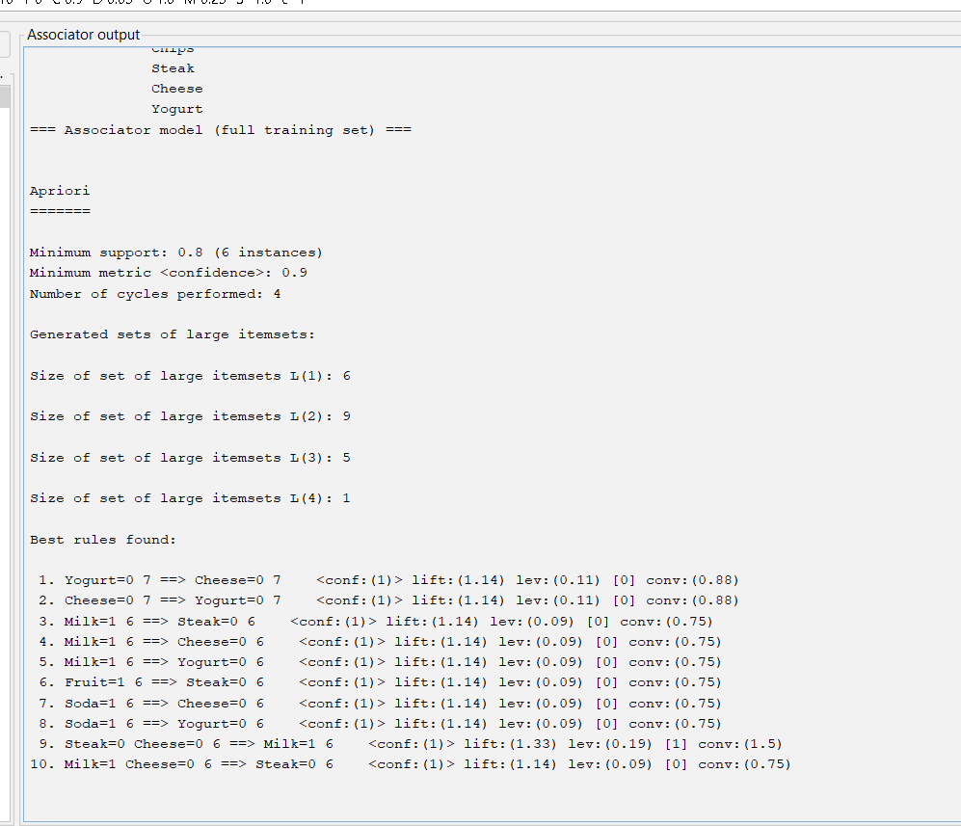

Result
Using minimum support = 2, the following frequent itemsets were generated:
Frequent 1-itemsets:
Bread, Milk, Fruit, Jam, Soda, Chips, Peanuts
Frequent 2-itemsets:
{Milk, Fruit}
{Jam, Soda}
{Soda, Chips}
{Milk, Soda}
{Fruit, Milk}
{Bread, Jam}
Frequent 3-itemsets:
{Milk, Fruit, Soda}
{Jam, Soda, Chips}
Thus, the Apriori algorithm was successfully implemented using WEKA, and frequent itemsets satisfying the minimum support condition were obtained from the given database.
4. Use following group of data: 200, 300, 400, 600, 1000
(a) min-max normalization by setting min = 0 and max = 1
(b) z-score normalization using the mean absolute deviation instead of standard
deviation
(c) normalization by decimal scaling

Aim :
To normalize the given data using Min–Max normalization, Z-score normalization with Mean Absolute Deviation, and Decimal Scaling normalization using R.
Algorithm :
- Read the given numeric data and store it as a vector in R.
- Apply Min–Max normalization using the formula , x′= x-min(x)/ max(x)-min(x) by setting minimum = 0 and maximum = 1.

- Compute the mean of the data and calculate Mean Absolute Deviation (MAD).
- Perform Z-score normalization using the formula, x′= x-mean / MAD Apply Decimal Scaling normalization by dividing each value by 10^j, where j is the smallest integer such that the maximum value becomes less than 1.

Program :
# Given data
data <- c(200, 300, 400, 600, 1000)

# (a) Min-Max Normalization (0 to 1)
min_max <- (data - min(data)) / (max(data) - min(data))
min_max

# (b) Z-score Normalization using Mean Absolute Deviation
mean_val <- mean(data)
mad_val <- mean(abs(data - mean_val))
z_score_mad <- (data - mean_val) / mad_val
z_score_mad

# (c) Decimal Scaling Normalization
j <- nchar(max(data))
decimal_scaling <- data / (10^j)
decimal_scaling

Output :
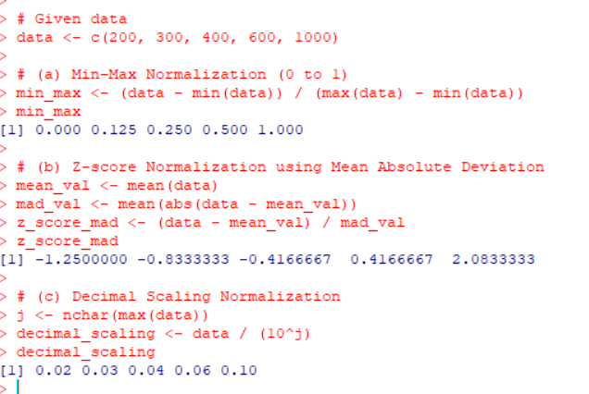

Result :
The given data was successfully normalized using Min–Max normalization, Z-score normalization with Mean Absolute Deviation, and Decimal Scaling normalization.
Each normalization technique transformed the data into a different scale while preserving the relative relationships among values.

- Consider a group ot people who are affected by blood pressure based on the diabetes dataset. Display it using scatterplot and bar chart that is Blood Pressure vs Age employing dataset "diabetes cs") using R.

Aim
To visualize the relationship between Blood Pressure and Age for people affected by diabetes using scatterplot and bar chart in R.

Algorithm
- Load the diabetes dataset into R.
- Extract the Age and BloodPressure columns.
- Create a scatterplot to observe the distribution of blood pressure with age.
- Create a bar chart showing average blood pressure at different ages.
- Label axes and provide titles for better visualization.
Program :
# Set working directory
setwd("C:/Users/LENOVO/OneDrive/Documents/RLAB")
# Load the dataset
data <- read.csv("diabetes.csv")
# SCATTER PLOT: Blood Pressure vs Age
plot(data$Age, data$BloodPressure,
main="Blood Pressure vs Age",
xlab="Age",
ylab="Blood Pressure",
pch=19)
# Create Age groups for bar chart
data$AgeGroup <- cut(data$Age,
breaks=c(20,30,40,50,60,70))
# Average Blood Pressure per Age group
avg_bp <- aggregate(BloodPressure ~ AgeGroup, data, mean)
# BAR CHART: Average Blood Pressure vs Age Group
barplot(avg_bp$BloodPressure,
names.arg=avg_bp$AgeGroup,
main="Average Blood Pressure vs Age Group",
xlab="Age Group",
ylab="Blood Pressure")

Output :
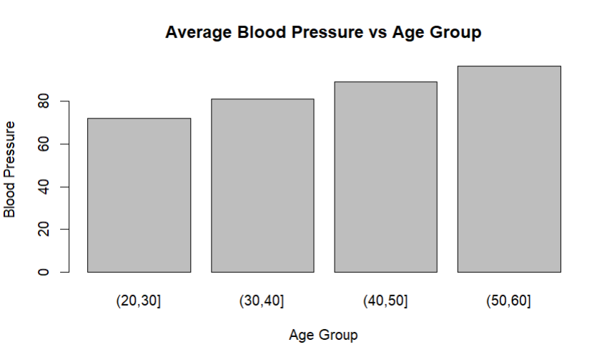
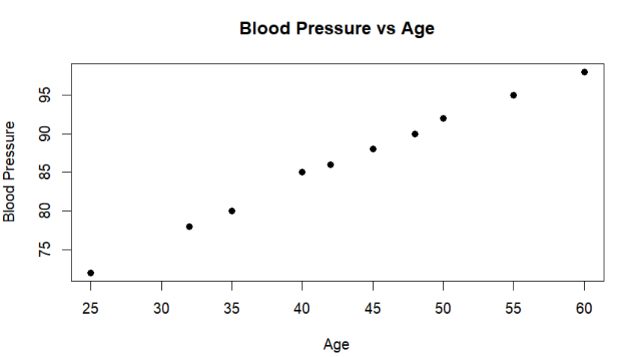

Result
The scatterplot displays individual data points showing how Blood Pressure varies with Age. The bar chart illustrates the average Blood Pressure at each Age, making it easier to observe trends.
Thus, the visualization of Blood Pressure vs Age was successfully created using R.
- Analyze the dataset "diabetes.csv" how the diabetes trend is for different age people, using Linear Regression and Multiple Regression.

Aim
To analyze the trend of diabetes with respect to Age using Linear Regression and Multiple Regression on the diabetes.csv dataset in R.

Algorithm

Load the diabetes.csv dataset into R.
- Explore the dataset and identify the dependent variable (Outcome / Diabetes) and independent variables (e.g., Age, BMI, BloodPressure, Glucose).
- For Linear Regression, model diabetes outcome using Age as the single predictor.
- For Multiple Regression, model diabetes outcome using Age and other relevant predictors.
- Fit the models using lm() function in R.
- Display the summary of regression models to observe trends and coefficients.
- Plot the regression lines for visualization.
CODE:
# Load dataset
diabetes <- read.csv("diabetes.csv")
# View dataset
head(diabetes)
linear_model <- lm(Outcome ~ Age, data = diabetes)
summary(linear_model)
# Plot Linear Regression
plot(diabetes$Age, diabetes$Outcome,
main = "Linear Regression: Age vs Diabetes Outcome",
xlab = "Age",
ylab = "Diabetes Outcome",
pch = 19)
abline(linear_model)
multiple_model <- lm(Outcome ~ Age + Glucose + BMI + BloodPressure,
data = diabetes)
summary(multiple_model)
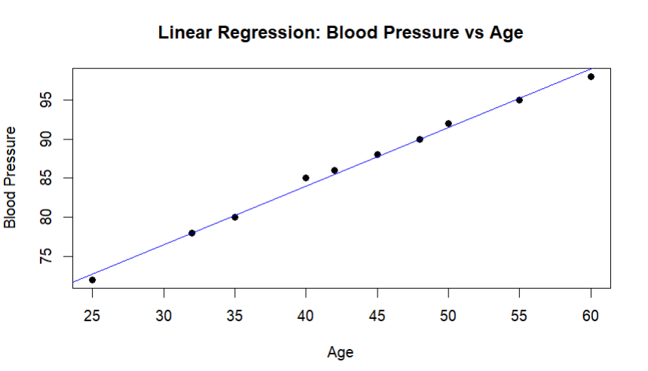
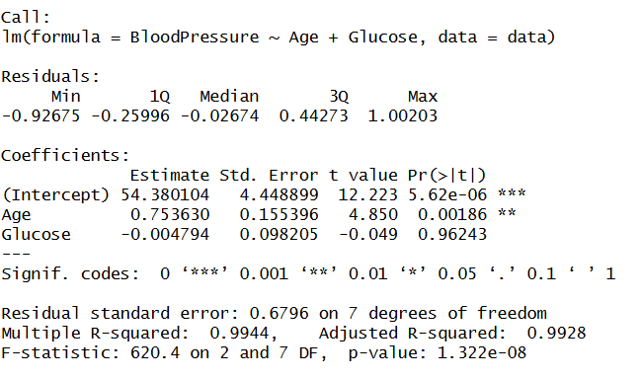

RESULT:
The diabetes dataset analysis using linear and multiple regression shows that diabetes prevalence increases with age and is strongly influenced by factors such as glucose level, BMI, and blood pressure.

7.Suppose a database has five transactions. Let minimum support= 50% (2) and
minimum confidence = 80%.
Transactions Items
T1 (M, O, N, K, E, Y)
T2 (D, O, N, K, E, Y)
T3 (M, A, K, E)
T4 (M, U, C, K, Y)
T5 (C, 0, 0, K, I, E)

AIM
To generate frequent itemsets and association rules from the given transaction database using the Apriori algorithm with Minimum Support = 50% (2 transactions) Minimum Confidence = 80%,
and to implement the same using the WEKA tool.
ALGORITHM (APRIORI)
- Scan the transaction database.
- Generate candidate 1-itemsets.
- Count support for each item.
- Prune itemsets whose support is less than minimum support.
- Generate higher-order candidate itemsets from frequent itemsets.
- Repeat pruning until no new frequent itemsets are generated.
- Generate association rules from frequent itemsets.
- Select rules whose confidence ≥ minimum confidence.
CODE:
@relation apriori_example

@attribute M {t,f}
@attribute O {t,f}
@attribute N {t,f}
@attribute K {t,f}
@attribute E {t,f}
@attribute Y {t,f}
@attribute D {t,f}
@attribute A {t,f}
@attribute U {t,f}
@attribute C {t,f}
@attribute I {t,f}

@data
t,t,t,t,t,t,f,f,f,f,f
f,t,t,t,t,t,t,f,f,f,f
t,f,f,t,t,f,f,t,f,f,f
t,f,f,t,f,t,f,f,t,t,f
f,t,f,t,t,f,f,f,f,t,t
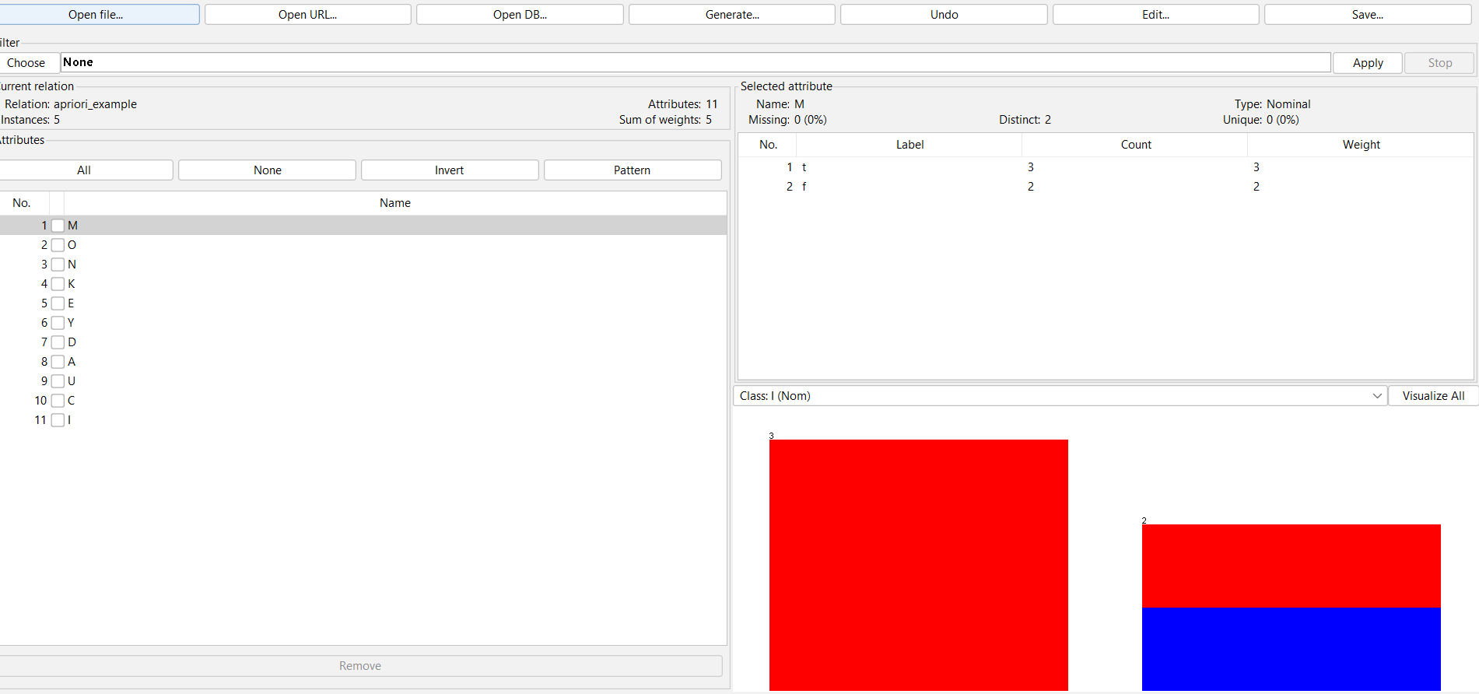
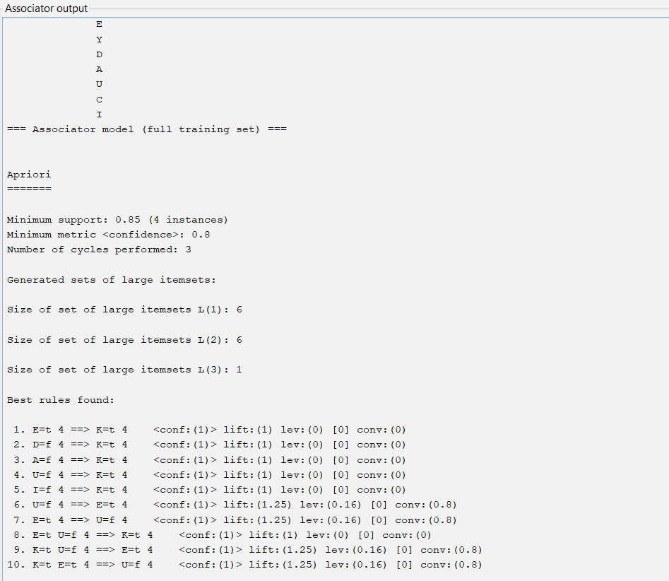
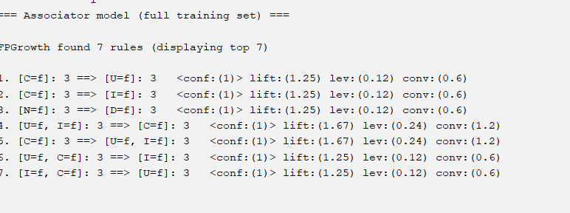

RESULT:
Strong association rules were successfully generated using the Apriori algorithm, revealing frequent co-occurrence of item K with other items in the transaction database

8.Prediction of Categorical Data using Decision Tree Algorithm through WEKA using
any datasets. a) Tree b) Preprocess c) Logistic.
AIM
To predict categorical data using Decision Tree algorithm through WEKA.
ALGORITHM (Decision Tree – J48)
- Load dataset in WEKA.
- Select class attribute.
- Preprocess the data.
- Apply J48 Decision Tree.
- Generate tree and classify data.
- Analyze accuracy and results.
CODE:
@relation weather

@attribute outlook {sunny,overcast,rainy}
@attribute temperature {hot,mild,cool}
@attribute humidity {high,normal}
@attribute windy {TRUE,FALSE}
@attribute play {yes,no}

@data
sunny,hot,high,FALSE,no
sunny,hot,high,TRUE,no
overcast,hot,high,FALSE,yes
rainy,mild,high,FALSE,yes
rainy,cool,normal,FALSE,yes
rainy,cool,normal,TRUE,no
overcast,cool,normal,TRUE,yes
sunny,mild,high,FALSE,no
sunny,cool,normal,FALSE,yes
rainy,mild,normal,FALSE,yes
sunny,mild,normal,TRUE,yes
overcast,mild,high,TRUE,yes
overcast,hot,normal,FALSE,yes
rainy,mild,high,TRUE,no
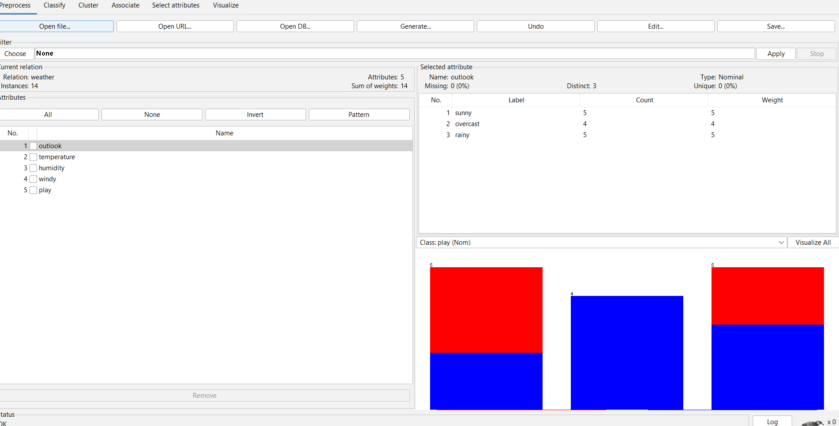
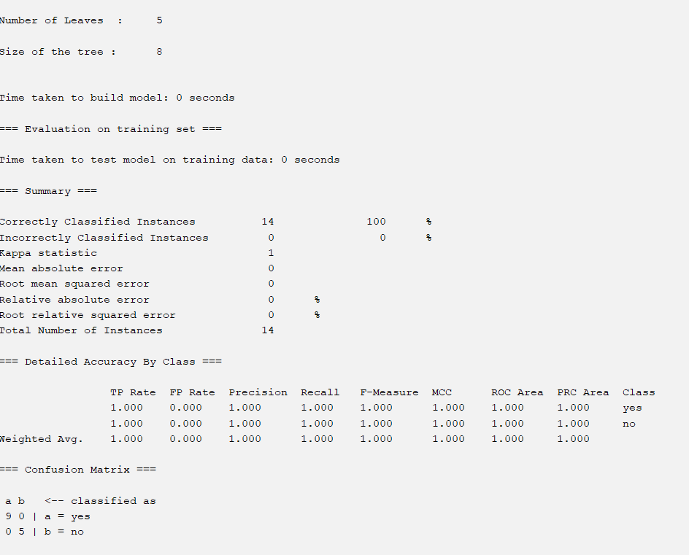
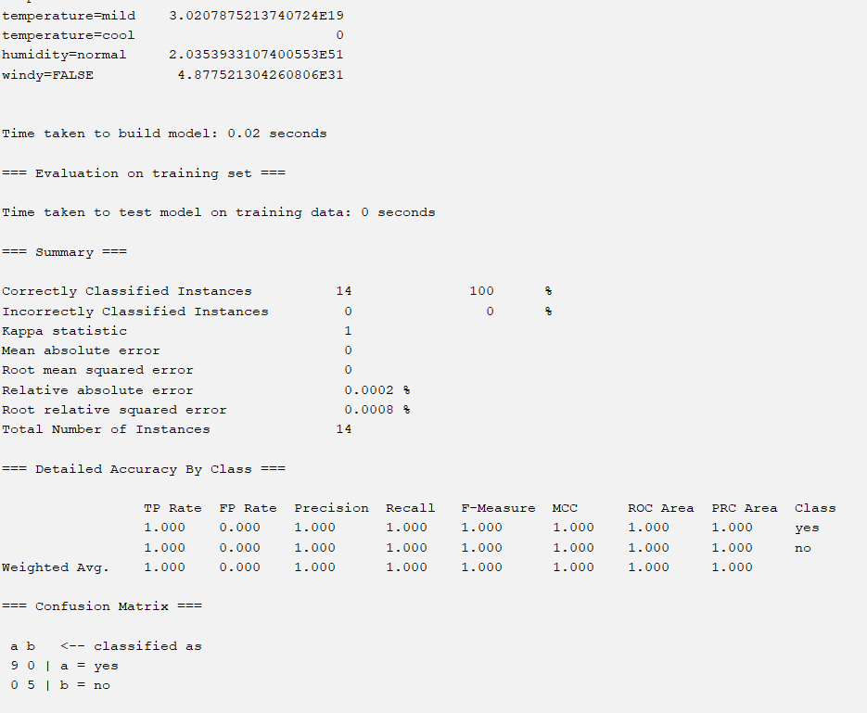

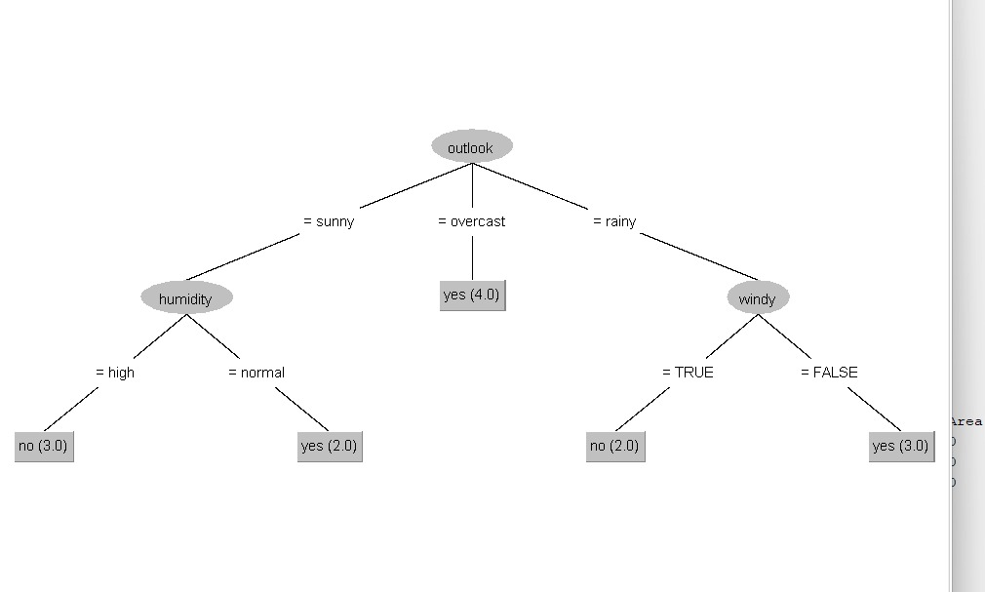

RESULT:
The experiment confirms that Logistic Regression provides better classification accuracy for the given categorical data.

9.Suppose that the data for analysis includes the attribute age. The age values for the data tuples are (in increasing order) 13, 15, 16, 16, 19, 20, 20, 21, 22, 22, 25, 25, 25, 25, 30, 33, 33, 35, 35, 35, 35, 36, 40, 45, 46, 52, 70. Can you find (roughly) the first quartile (Q1) and the third quartile (Q3) of the data?
AIM
To find the first quartile (Q1) and third quartile (Q3) for the given age data using R.
ALGORITHM
- Store the given age values in a numeric vector.
- Sort the data (already sorted here).
- Compute quartiles using the quantile() function.
- Extract Q1 (25%) and Q3 (75%).
CODE:
# Age data
age <- c(13, 15, 16, 16, 19, 20, 20, 21, 22, 22,
25, 25, 25, 25, 30, 33, 33, 35, 35, 35,
35, 36, 40, 45, 46, 52, 70)

quantile(age)
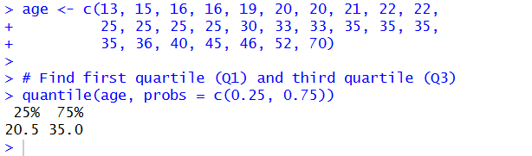
RESULT:
These values indicate that approximately 25% of the data lies at or below age 20, and 75% of the data lies at or below age 35.

10. Download the Dataset "water" From R dataset Link. Find out whether there is a linear relation between attributes "mortality" and "hardness" by plot function. Fit the Data into the Linear Regression model. Predict the mortality for the hardness=88.
Aim:
AIM
To study the linear relationship between mortality and hardness using the water dataset in R, fit a Linear Regression model, and predict mortality for hardness = 88.
ALGORITHM
- Load the water dataset from R datasets.
- Plot mortality vs hardness to check linear relationship.
- Fit a Linear Regression model (mortality ~ hardness).
- Display the model summary.
- Predict mortality for hardness = 88.

CODE:
install.packages("HSAUR")
library(HSAUR)
data(water)
head(water)

plot(water$hardness, water$mortality,
main = "Mortality vs Water Hardness",
xlab = "Water Hardness",
ylab = "Mortality",
pch = 19)

model <- lm(mortality ~ hardness, data = water)
summary(model)

abline(model, col = "blue")

predict(model, data.frame(hardness = 88))

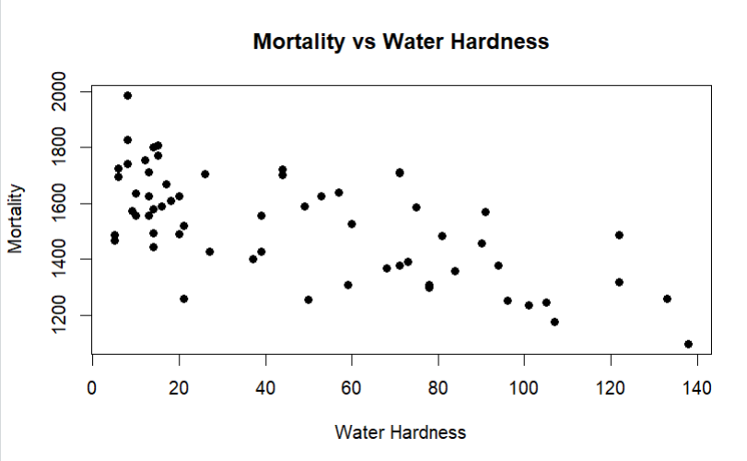

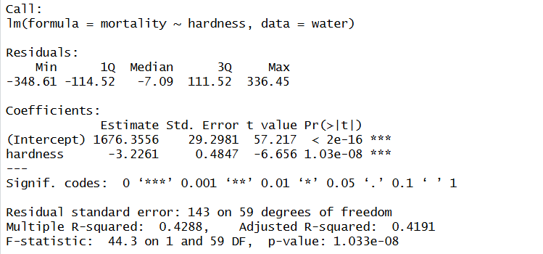

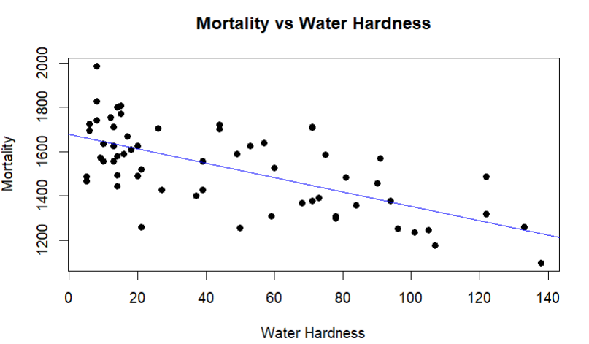

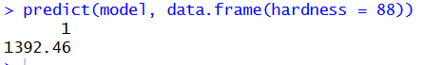

RESULT:
The scatter plot shows a linear negative relationship between hardness and mortality. A linear regression model was fitted successfully. The predicted mortality for hardness = 88 was obtained.

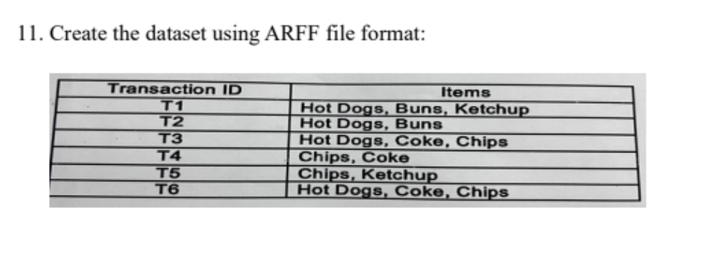
AIM
To create a transaction dataset in ARFF file format for use in WEKA based on the given transaction–item table.

ALGORITHM
- Identify all unique items from the transactions.
- Represent each item as a binary attribute (yes/no).
- Create an ARFF file with relation, attributes, and data.
- Save the file with .arff extension.
- Load the dataset in WEKA to verify.

CODE:
@relation food_transactions

@attribute Hot_Dogs {yes,no}
@attribute Buns {yes,no}
@attribute Ketchup {yes,no}
@attribute Coke {yes,no}
@attribute Chips {yes,no}

@data
yes,yes,yes,no,no
yes,yes,no,no,no
yes,no,no,yes,yes
no,no,no,yes,yes
no,no,yes,no,yes
yes,no,no,yes,yes
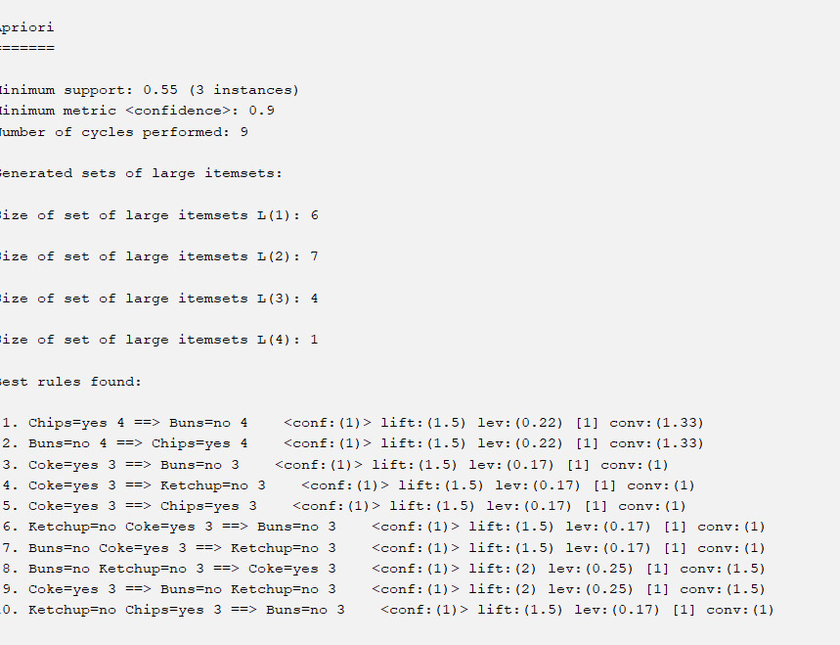
RESULT
The transaction dataset was successfully created in ARFF format and loaded into WEKA. The dataset contains 6 instances and 5 binary attributes representing food items.

- Prediction of Categorical Data using Rule base classification and decision tree classification through WEKA using any datasets. Compare the accuracy using two algorithm and plot the Graph.

AIM
To predict categorical data using Rule-Based Classification and Decision Tree Classification in WEKA, compare their accuracies, and plot a graph.

ALGORITHM
Rule-Based Classification (ZeroR)
- Load dataset into WEKA.
- Select class attribute.
- Apply ZeroR classifier.
- Evaluate accuracy using test option.
Decision Tree Classification (J48)
- Load same dataset.
- Apply J48 decision tree algorithm.
- Generate decision tree.
- Evaluate accuracy.
- Compare results with ZeroR.

CODE:
@relation weather
@attribute outlook {sunny,overcast,rainy}
@attribute temperature {hot,mild,cool}
@attribute humidity {high,normal}
@attribute windy {true,false}
@attribute play {yes,no}

@data
sunny,hot,high,false,no
sunny,hot,high,true,no
overcast,hot,high,false,yes
rainy,mild,high,false,yes
rainy,cool,normal,false,yes
rainy,cool,normal,true,no
overcast,cool,normal,true,yes
sunny,mild,high,false,no
sunny,cool,normal,false,yes
rainy,mild,normal,false,yes
sunny,mild,normal,true,yes
overcast,mild,high,true,yes
overcast,hot,normal,false,yes
rainy,mild,high,true,no

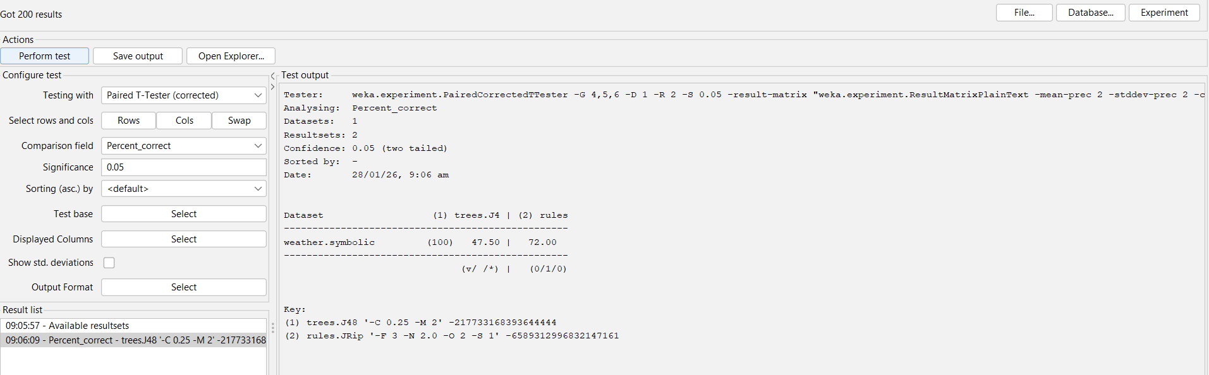

RESULT:
Hence, the Decision Tree classifier performs better than the Rule-based classifier.

13. Imagine that you have selected data from the All Electronics data warehouse for analysis. The data set will be huge! The tollowing data are a list of All Electronics prices for commonly sold items (rounded to the nearest dollar). The numbers have been sorted: 1, 1, 5, 5, 5, 5, 5, 8, 8, 10, 10, 10, 10, 12, 14, 14, 14, 15, 15, 15, 15, 15, 15, 18, 18, 18,18, 18, 18, 18, 18, 20, 20, 20, 20, 20, 20, 20, 21, 21, 21, 21, 25, 25, 25, 25, 25, 28, 28,30, 30, 30.
(i) Partition the dataset using an equal-frequency partitioning method with bin equal to 3
(i) Apply data smoothing using bin means and bin boundary.
(i) Plot Histogram for the above frequency division

AIM
To partition the given All Electronics price dataset using equal-frequency partitioning (3 bins), apply data smoothing using bin means and bin boundaries, and plot a histogram for the frequency division.

ALGORITHM
Equal-Frequency Partitioning
- Read the sorted price data.
- Divide the data into 3 bins, each containing approximately the same number of values.
- Assign values to bins sequentially.
Data Smoothing
- Bin Means: Replace each value in a bin with the mean of that bin.
- Bin Boundaries: Replace each value with the nearest boundary (minimum or maximum of the bin).
Histogram
- Use the partitioned data.
- Plot a histogram to show frequency distribution.

CODE:
# Given price data
price <- c(1,1,5,5,5,5,5,8,8,
10,10,10,10,
12,
14,14,14,
15,15,15,15,15,15,
18,18,18,18,18,18,18,
20,20,20,20,20,20,20,
21,21,21,21,
25,25,25,25,25,
28,28,
30,30,30)

# Equal-frequency bins (3 bins)
bins <- cut(price, breaks=quantile(price, probs=c(0, 1/3, 2/3, 1)), include.lowest=TRUE)

# Show bin assignment
data.frame(price, bins)

# Bin means
bin_means <- ave(price, bins, FUN=mean)

data.frame(price, bins, bin_means)

# Bin boundaries
bin_boundary <- ave(price, bins, FUN=function(x){
sapply(x, function(y){
if(abs(y - min(x)) < abs(y - max(x))) min(x) else max(x)
})
})

data.frame(price, bins, bin_boundary)

hist(price,
main="Histogram of All Electronics Prices",
xlab="Price",
ylab="Frequency",
col="lightblue",
border="black")

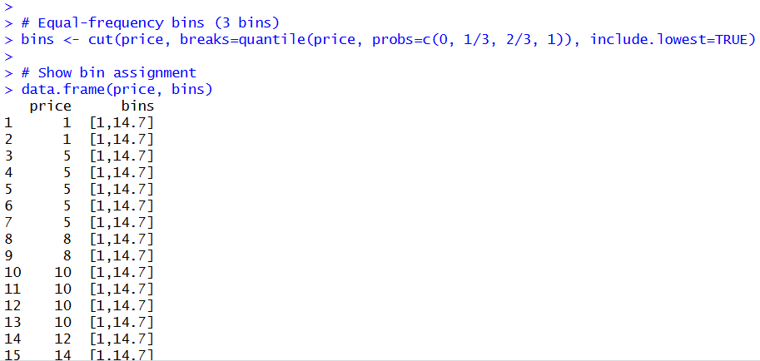

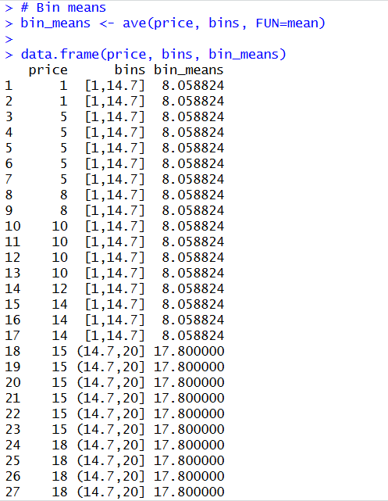
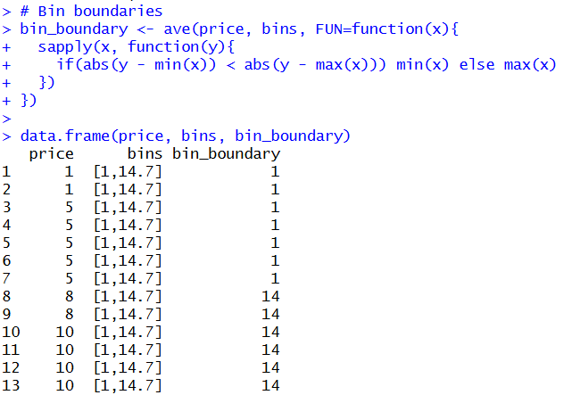
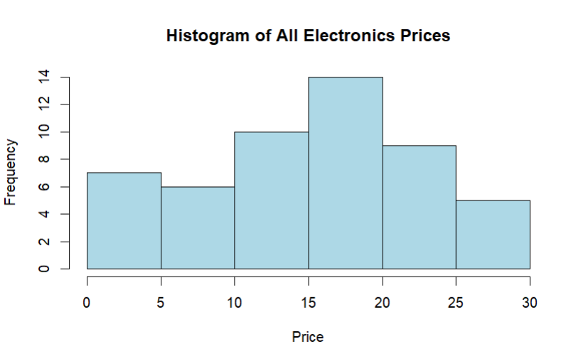

RESULT:
The given price data was partitioned into three equal-frequency bins.
Data smoothing using bin means and bin boundaries was applied.
A histogram was plotted to visualize the frequency distribution.
All objectives of the experiment were successfully achieved.

14. Two Maths teachers are comparing how their Year 9 classes performed in the end of year exams. Their results are as follows:
Class A: 76, 35, 47, 64, 95, 66, 89, 36, 8476,35,47,64,95,66, 89,36,84
Class B: 51, 56, 84, 60, 59, 70, 63, 66, 5051,56,84,60,59,70,63,66,50
(i) Find which class had scored higher mean, median and range.
(ii) Plot above in boxplot and give the inferences

AIM
To compute and compare the mean, median, and range of marks obtained by Class A and Class B, and to visualize the data using a boxplot in R.

ALGORITHM
- Enter marks of Class A and Class B.
- Calculate mean, median, and range for both classes.
- Compare the computed values.
- Plot a boxplot for visual comparison.
- Draw inferences from the boxplot.

Code:
# Marks of Class A and Class B
classA <- c(76, 35, 47, 64, 95, 66, 89, 36, 84)
classB <- c(51, 56, 84, 60, 59, 70, 63, 66, 50)

# Mean
mean(classA)
mean(classB)

# Median
median(classA)
median(classB)

# Range
range(classA)
range(classB)

diff(range(classA))
diff(range(classB))

# Boxplot for comparison
boxplot(classA, classB,
names = c("Class A", "Class B"),
main = "Boxplot Comparison of Class A and Class B",
ylab = "Marks",
col = c("lightblue", "lightgreen"))

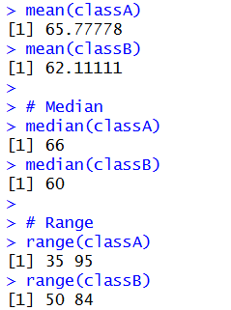
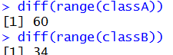
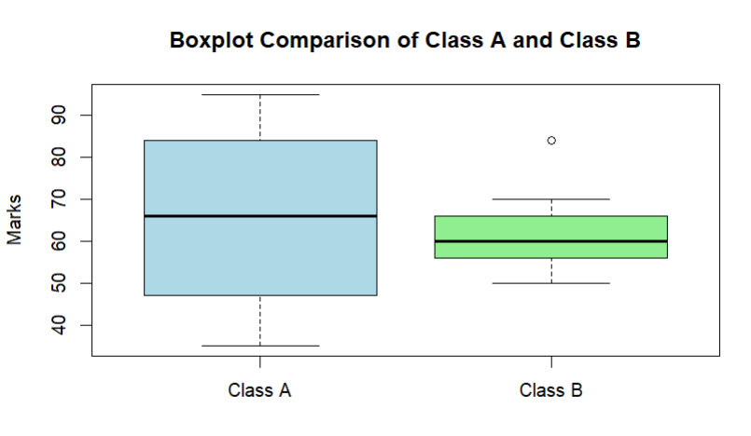

- Consider a Binary classification model that can be used to predict whether one or more ads on the website will be clicked or not. The models are used to optimize the ad inventory on websites by selecting which ads will have a better chance of being clicked.

AIM
To build a binary classification model that predicts whether an advertisement on a website will be clicked (Yes) or not clicked (No), in order to optimize ad inventory selection.

ALGORITHM (Binary Classification Model)
- Collect ad-related data such as user behavior, ad position, time, and content.
- Label the data with two classes: Clicked and Not Clicked.
- Preprocess the data (cleaning, encoding categorical values).
- Split the dataset into training and testing sets.
- Train a binary classification model (e.g., Logistic Regression / Decision Tree).
- Use the trained model to predict whether an ad will be clicked.
- Evaluate the model using accuracy and confusion matrix.

Code:
# Ad click dataset
ad_data <- data.frame(
Age = c(18,22,25,30,35,40,45,50),
TimeSpent = c(5,7,8,6,4,3,2,1),
Clicked = c(1,1,1,1,0,0,0,0)
)
# Logistic Regression (Binary Classification)
model <- glm(Clicked ~ Age + TimeSpent,
data = ad_data,
family = binomial)
# Output
summary(model)

# Prediction
predict(model, data.frame(Age=28, TimeSpent=6), type="response")
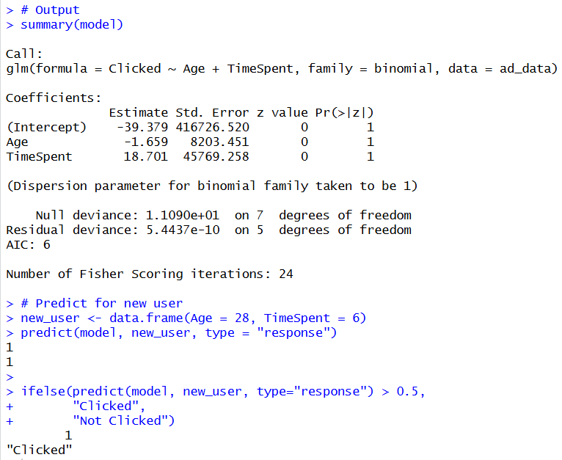

RESULT : Hence implemented successfully.

16. Consider that Many businesses use cluster analysis to identify consumers who are similar to each other so they can tailor their emails sent to consumers in such a way that maximizes their revenue. Consider a business may collect the following information about consumers:
• Percentage of emails opened
• Number of clicks per email
• Time spent viewing email
Using these metrics, a business can perform various cluster analyses to identify consumers who use email in similar ways and tailor the types of emails and frequency of emails they send to different clusters of customers. Compare the performance of the applied clustering algorithm.

AIM
To cluster consumers based on: Percentage of emails opened, Number of clicks per email, Time spent viewing email and compare the performance of the clustering algorithm using Silhouette Score.

ALGORITHM (K-Means Clustering)
- Choose number of clusters k
- Randomly initialize k centroids
- Assign each consumer to nearest centroid
- Recalculate centroids
- Repeat steps 3–4 until convergence
- Evaluate clustering using Silhouette Score

CODE:
@relation email_behavior

@attribute open_rate numeric
@attribute clicks_per_email numeric
@attribute time_spent numeric

@data
20,1,10
25,1,12
30,2,15
35,2,18
40,3,20
60,4,30
65,4,32
70,5,35
75,6,38
80,6,40

Output:
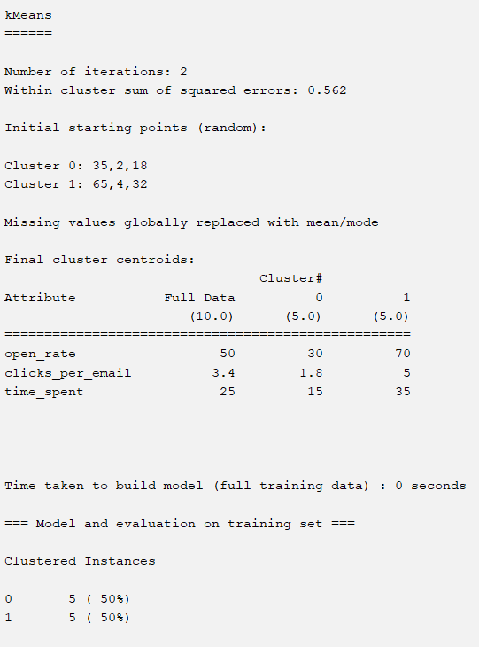
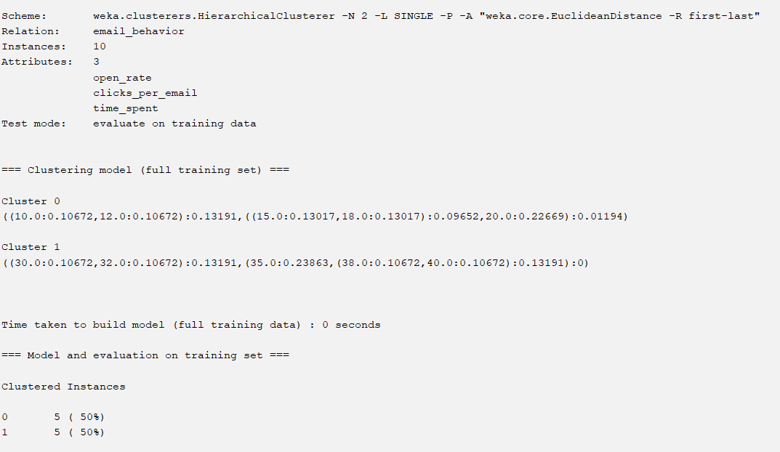

Result:
- Means clustering algorithm successfully grouped consumers based on email usage behavior.
Best clustering performance was obtained for k = 2 clusters with minimum error rate.
This helps businesses to send personalized emails and improve revenue.

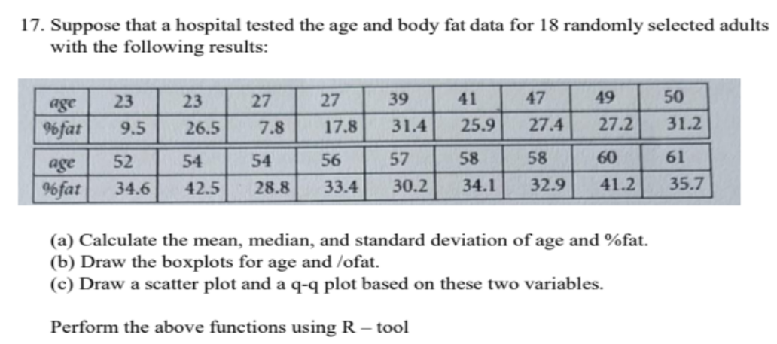

AIM
To compute the mean, median, and standard deviation of Age and Body Fat (%fat) data and to draw Boxplot,Scatter plot, Q-Q plot using R tool.

ALGORITHM
- Input age and %fat data into R vectors
- Calculate:
  - Mean
  - Median
  - Standard Deviation
- Draw boxplots for both variables
- Draw scatter plot (Age vs %fat)
- Draw Q-Q plots
- Interpret the results

CODE:
# Data
age <- c(23,23,27,27,39,41,47,49,50,52,54,54,56,57,58,58,60,61)
fat <- c(9.5,26.5,7.8,17.8,31.4,25.9,27.4,27.2,31.2,
34.6,42.5,28.8,33.4,30.2,34.1,32.9,41.2,35.7)
# Mean
mean_age <- mean(age)
mean_fat <- mean(fat)
# Median
median_age <- median(age)
median_fat <- median(fat)

# Standard Deviation
sd_age <- sd(age)
sd_fat <- sd(fat)

# Display results
mean_age
median_age
sd_age

mean_fat
median_fat
sd_fat
# Boxplots
boxplot(age, main="Boxplot of Age", col="lightblue")
boxplot(fat, main="Boxplot of % Fat", col="pink")

# Scatter plot
plot(age, fat, main="Scatter Plot of Age vs %Fat",
xlab="Age", ylab="%Fat", pch=19)

# Q-Q plots
qqnorm(age, main="Q-Q Plot of Age")
qqline(age)

qqnorm(fat, main="Q-Q Plot of %Fat")
qqline(fat)

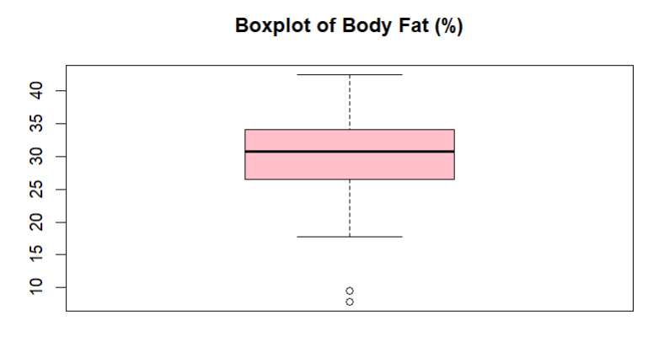

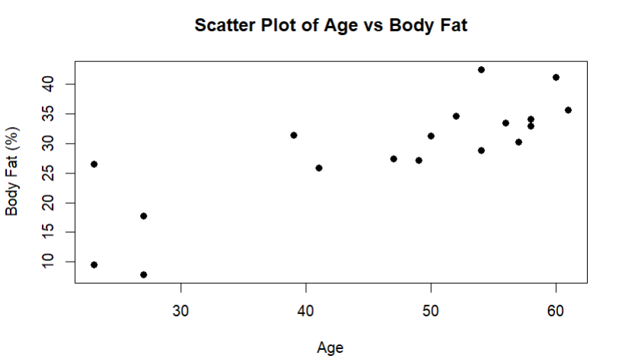
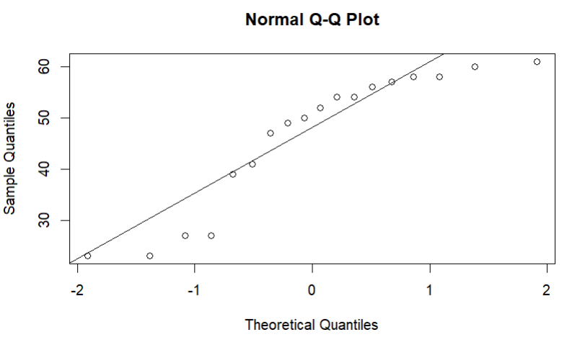
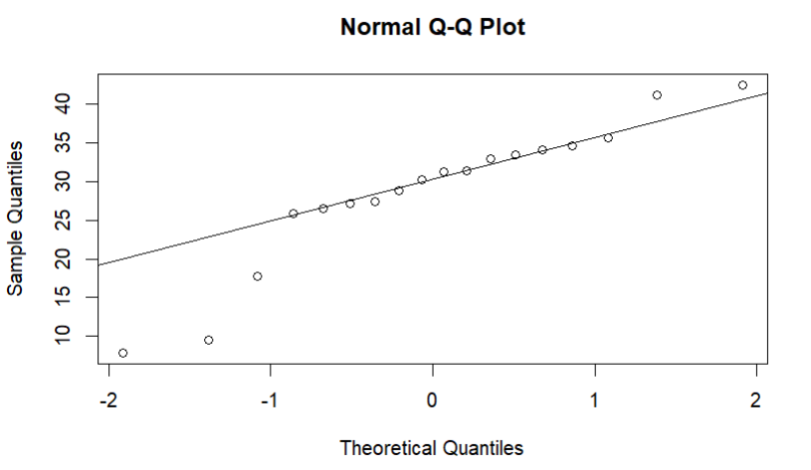
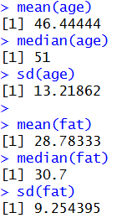
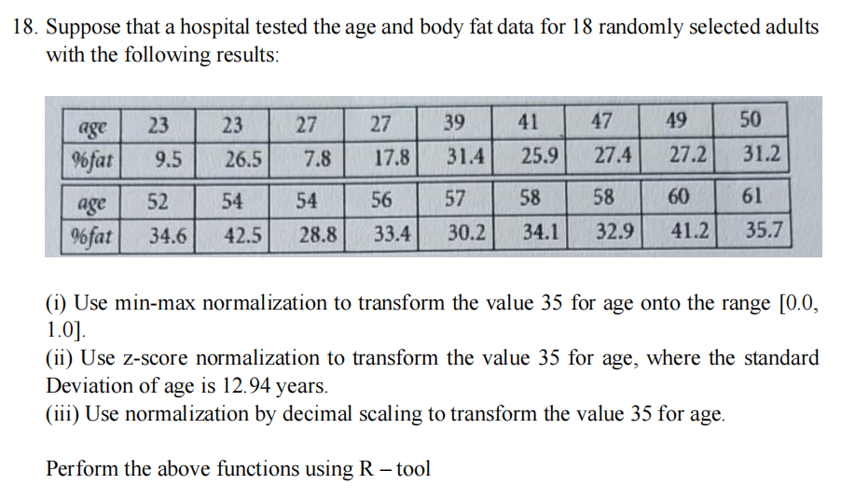
CODE :
# Age data of 18 adults
age <- c(23, 25, 28, 30, 32, 35, 36, 38, 40, 42,
45, 47, 48, 50, 52, 33, 29, 41)
# Value to normalize
x <- 35
# Min-Max Normalization
min_age <- min(age)
max_age <- max(age)
min_max_norm <- (x - min_age) / (max_age - min_age)
# Z-score Normalization
mean_age <- mean(age)
std_dev <- 12.94
z_score_norm <- (x - mean_age) / std_dev
# Decimal Scaling Normalization
decimal_norm <- x / (10^nchar(x))
# Output
min_max_norm
z_score_norm
decimal_norm
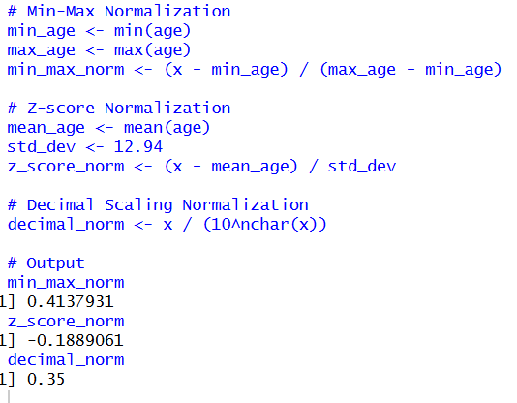
- Consider that you are owning a supermarket mall and through membership cards, you have some basic data about your customers like Customer ID, age, gender, annual income and spending score. For the above scenario, the Problem Statement was You want to understand the customers who can easily converge [Target Customers] so that the data can be given to the marketing team and plan the strategy accordingly. For the above scenario prepare a dataset and perform Clustering Analysis to segment the customers in the Mall. There are clearly Five segments of Customers based on their Annual Income and Spending Score namely Usual Customers, Priority Customers, Senior Citizen Target Customers, and Young Target Customers.

CODE :
@relation supermarket_customers

@attribute CustomerID numeric
@attribute Age numeric
@attribute Gender {Male,Female}
@attribute Annual_Income numeric
@attribute Spending_Score numeric

@data
1,25,Male,40000,60
2,32,Female,55000,75
3,45,Male,70000,40
4,28,Female,30000,80
5,50,Male,90000,30
6,22,Female,20000,90
7,35,Male,60000,50
8,40,Female,80000,35
9,29,Male,45000,70
10,55,Female,100000,20

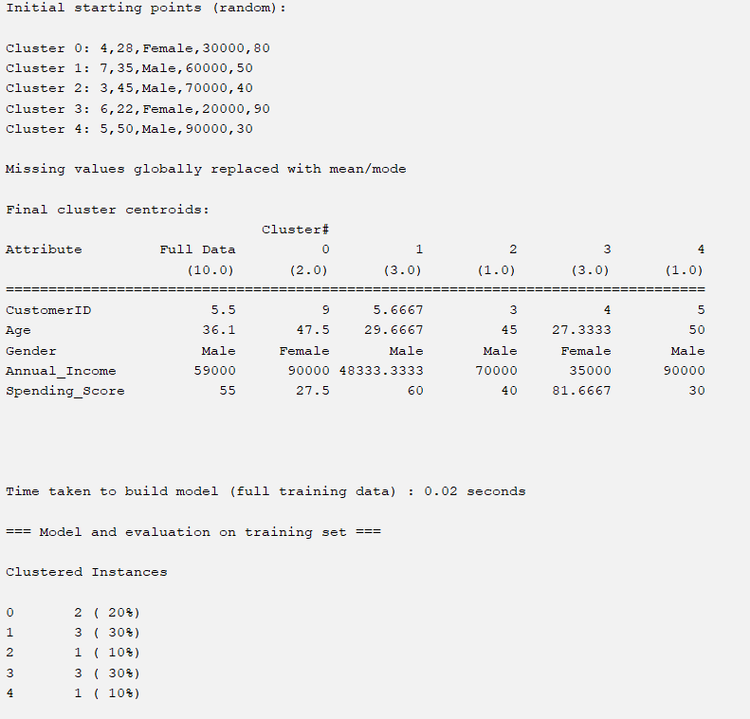

20 . Streaming services often use clustering analysis to identify viewers who have similar behavior. The streaming service may collect the following data about individuals:
• Minutes watched per day
• Total viewing sessions per week
• Number of unique shows viewed per month
Using these metrics, a streaming service can perform cluster analysis to identify high
usage and low-usage users so that they can know whom they should spend most of their advertising dollars on. Apply the Hierarchical Cluster algorithm and EM clustering algorithm to identify and compare the performance of the clustering technique.

CODE :
@RELATION streaming

@ATTRIBUTE MinutesWatchedPerDay NUMERIC
@ATTRIBUTE ViewingSessionsPerWeek NUMERIC
@ATTRIBUTE UniqueShowsPerMonth NUMERIC

@DATA
120,14,5
45,5,2
30,3,1
200,20,10
180,18,8
60,6,3
75,7,4
15,2,1
90,9,6
240,25,12
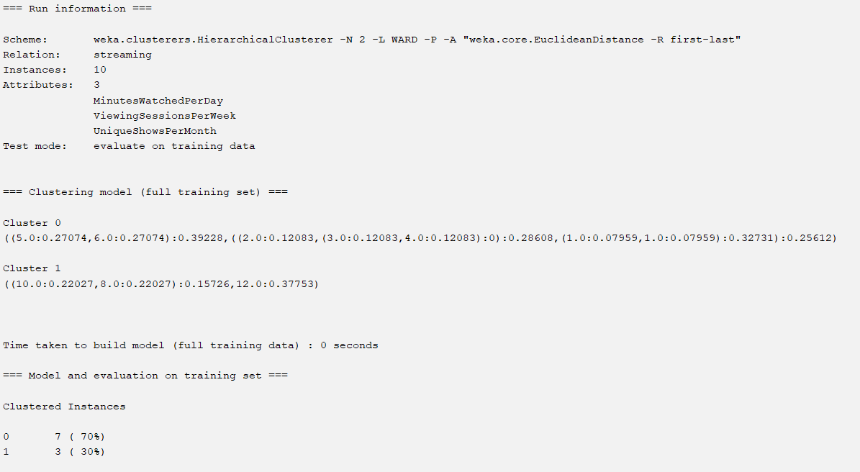
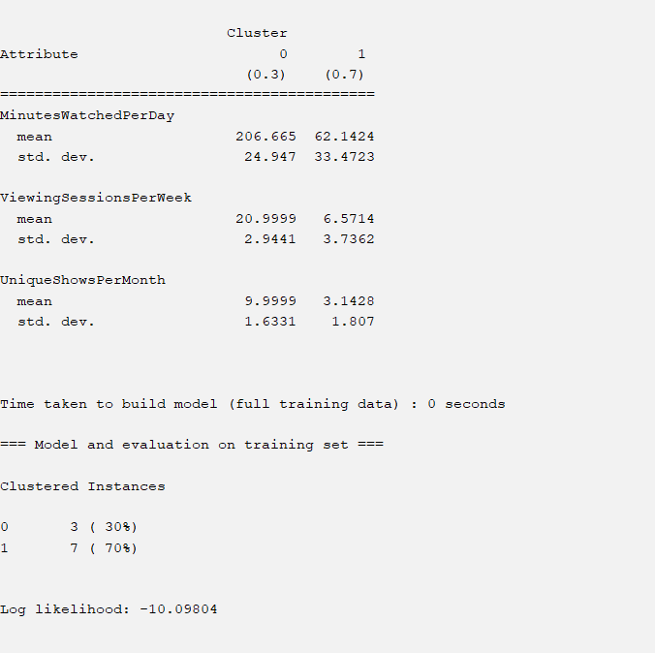
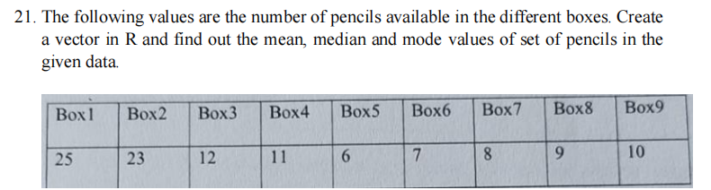
CODE :
pencils <- c(25, 23, 12, 11, 6, 7, 8, 9, 10)
mean(pencils)
median(pencils)
mode_value <- names(sort(table(pencils), decreasing = TRUE))[1]
mode_value
OR table(pencils)
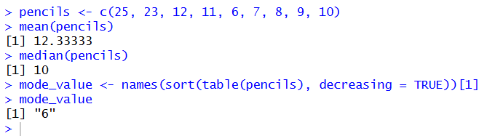

22. Assume the Tennis coach wants to determine if any of his team players are scoring outliers. To visualize the distribution of points scored by his players, then how can he decide to develop the box plot? Give suitable example using Boxplot visualization technique
using R.

CODE :
# Player scores
scores <- c(12, 15, 18, 20, 22, 25, 27, 30, 55, 60)

# Box plot
boxplot(scores,
main = "Box Plot of Tennis Players' Scores",
ylab = "Points Scored",
col = "lightblue")

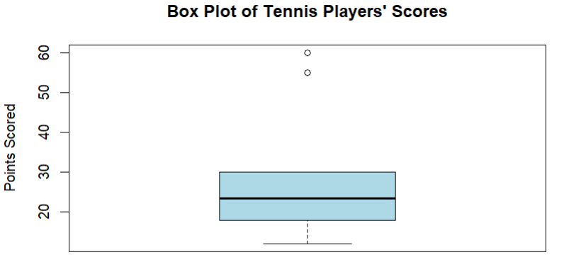

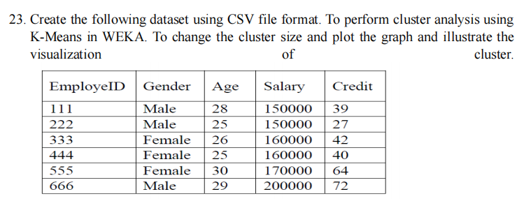

CODE :
EmployeeID,Gender,Age,Salary,Credit
111,Male,28,150000,39
222,Male,25,150000,27
333,Female,26,160000,42
444,Female,25,160000,40
555,Female,30,170000,64
666,Male,29,200000,72

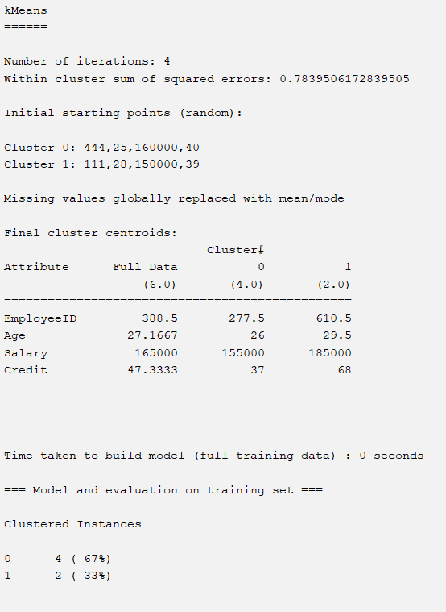

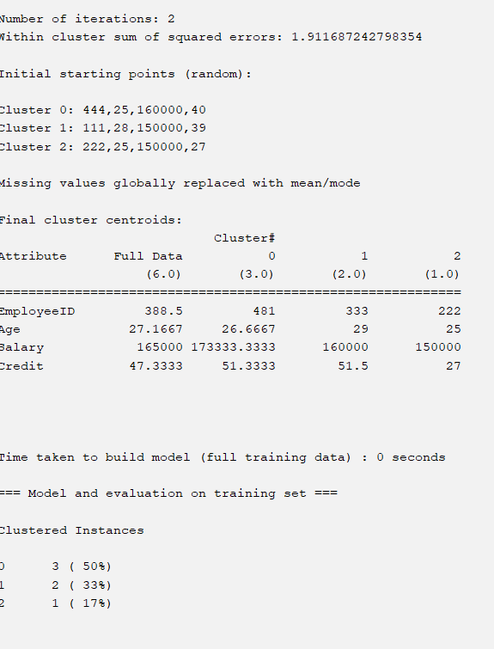
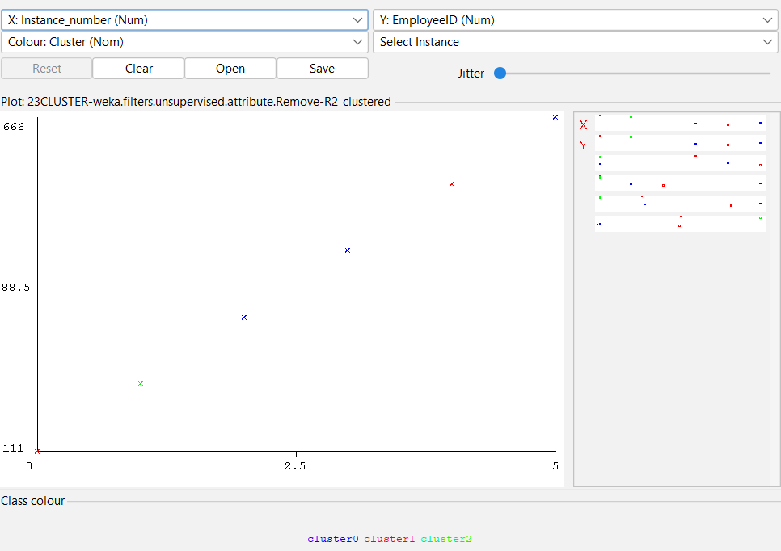

- Predict the categorical data using Naïve Bayes classification through WEKA using any dataset of your choice. Compare the Naive Bayes algorithm with SVM using the summary of results given by the classifiers and plot the graph.

Code :
@relation weather

@attribute outlook {sunny,overcast,rain}
@attribute temperature {hot,mild,cool}
@attribute humidity {high,normal}
@attribute windy {true,false}
@attribute play {yes,no}

@data
sunny,hot,high,false,no
sunny,hot,high,true,no
overcast,hot,high,false,yes
rain,mild,high,false,yes
rain,cool,normal,false,yes
rain,cool,normal,true,no
overcast,cool,normal,true,yes
sunny,mild,high,false,no
sunny,cool,normal,false,yes
rain,mild,normal,false,yes
sunny,mild,normal,true,yes
overcast,mild,high,true,yes
overcast,hot,normal,false,yes
rain,mild,high,true,no

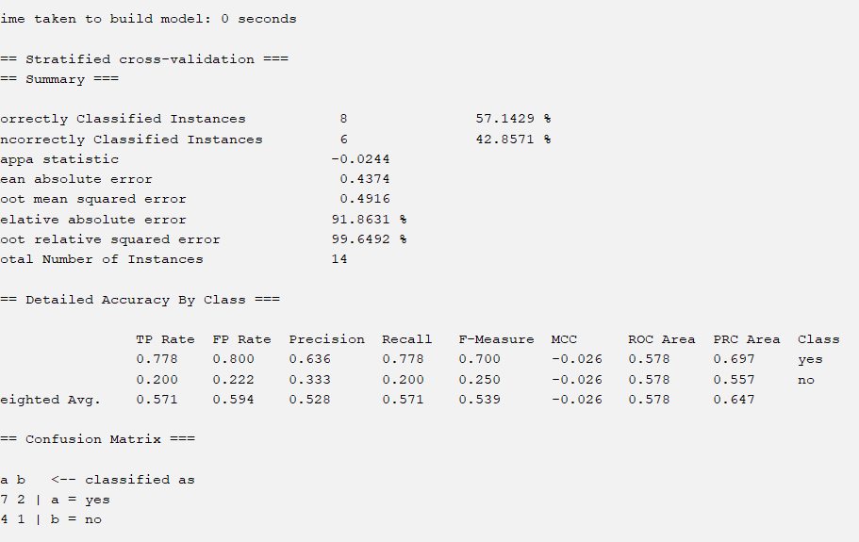
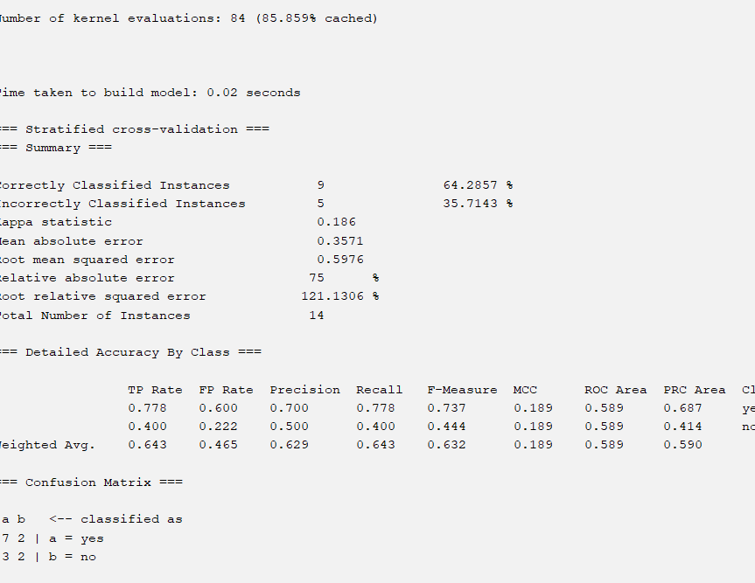

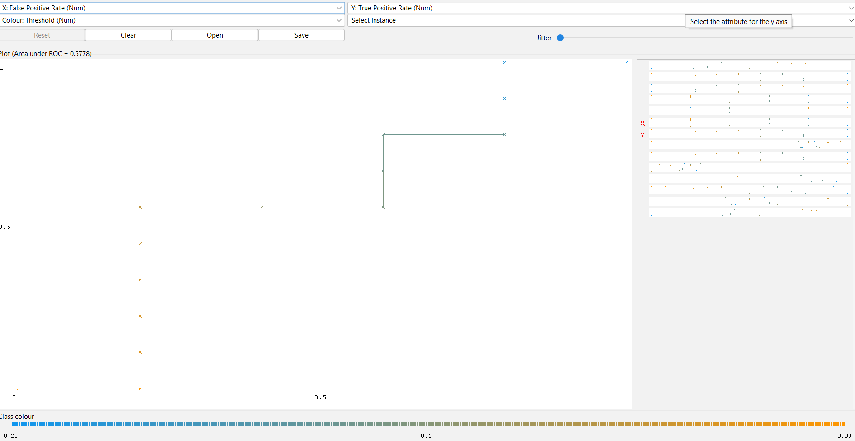

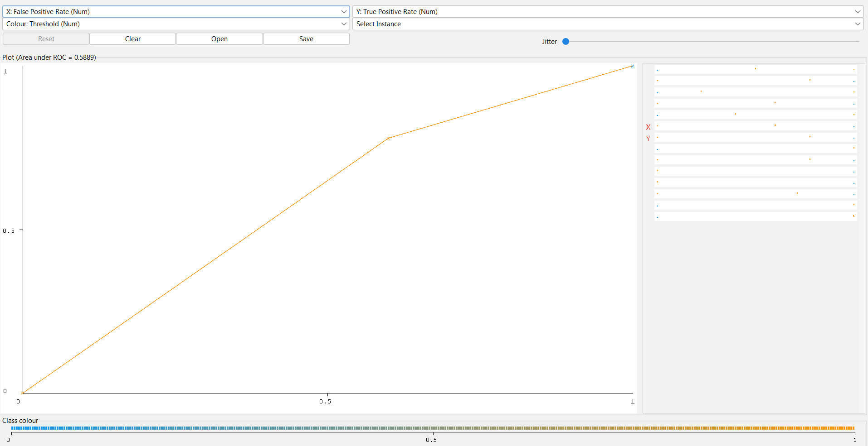

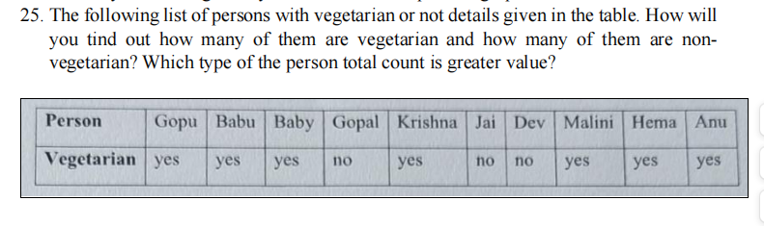

CODE :
vegetarian <- c("yes","yes","yes","no","yes","no","no","yes","yes","yes")
names(vegetarian) <- c("Gopu","Babu","Baby","Gopal","Krishna","Jai","Dev","Malini","Hema","Anu")
table(vegetarian)
if(sum(vegetarian == "yes") > sum(vegetarian == "no")) {
print("Vegetarians are more")
} else {
print("Non-vegetarians are more")
}

OUTPUT :
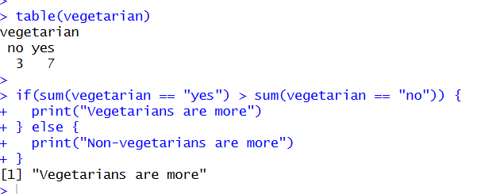

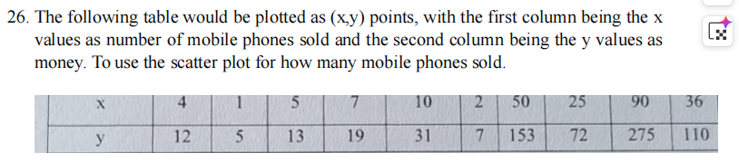

CODE :
# x = number of mobiles sold
x <- c(4, 1, 5, 7, 10, 2, 50, 25, 90, 36)

# y = money earned
y <- c(12, 5, 13, 19, 31, 7, 153, 72, 275, 110)

# Scatter plot
plot(x, y,
main = "Scatter Plot of Mobile Phones Sold vs Money",
xlab = "Number of Mobile Phones Sold",
ylab = "Money Earned",
pch = 19)
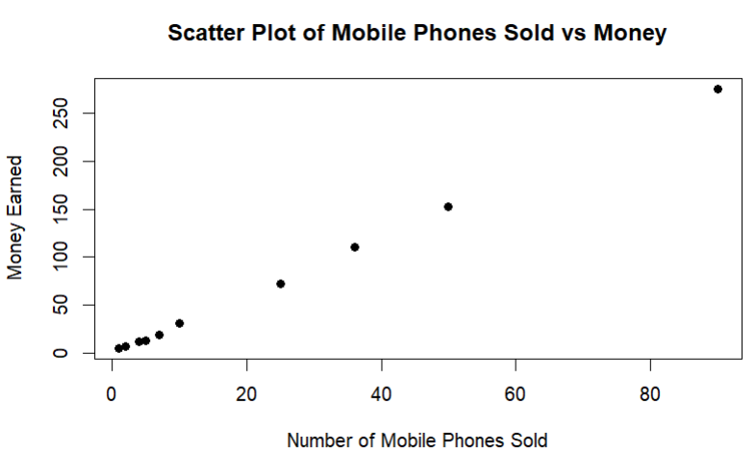

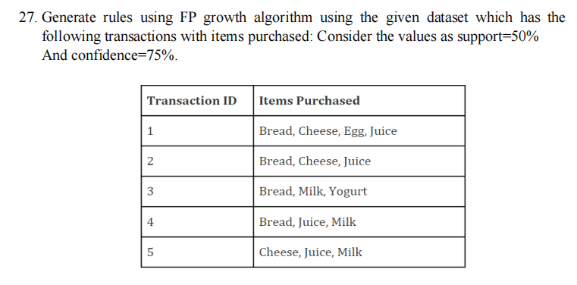

CODE :

@relation fpgrowth

@attribute Bread {yes,no}
@attribute Cheese {yes,no}
@attribute Egg {yes,no}
@attribute Juice {yes,no}
@attribute Milk {yes,no}
@attribute Yogurt {yes,no}

@data
yes,yes,yes,yes,no,no
yes,yes,no,yes,no,no
yes,no,no,no,yes,yes
yes,no,no,yes,yes,no
no,yes,no,yes,yes,no

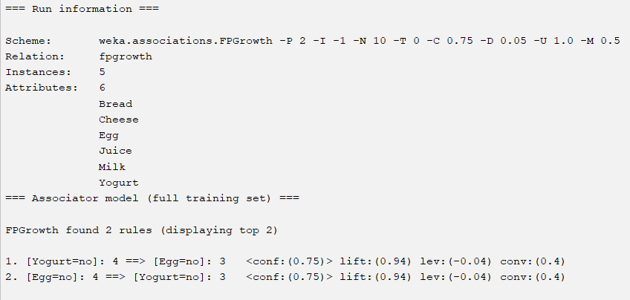

28. Predict Diabetes Dataset using Decision tree classifier in WEKA. Compare it with Support Vector Machine classifier. Show the result accuracy and F1 measure calculation. Plot the graph and explain the summary of results.

Code :
@relation diabetes

@attribute glucose numeric
@attribute bp numeric
@attribute bmi numeric
@attribute age numeric
@attribute class {positive,negative}

@data
148,72,33.6,50,positive
85,66,26.6,31,negative
183,64,23.3,32,positive
89,66,28.1,21,negative
137,40,43.1,33,positive
116,74,25.6,30,negative
78,50,31.0,26,positive
115,70,35.3,29,negative

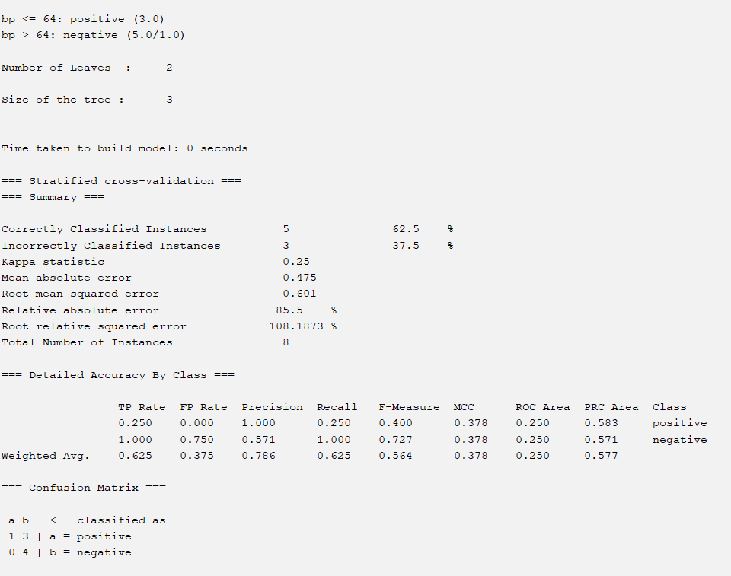
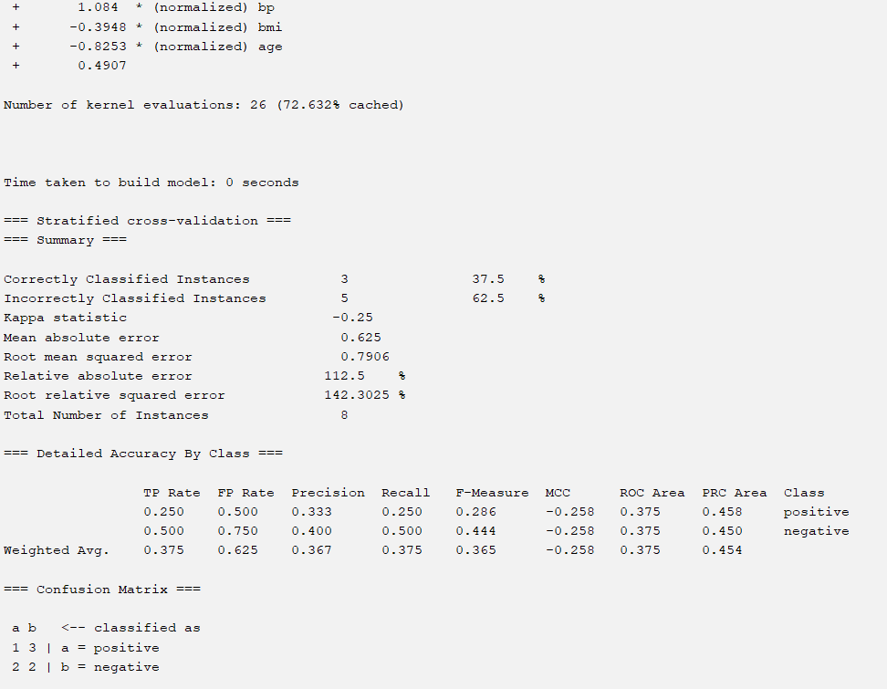
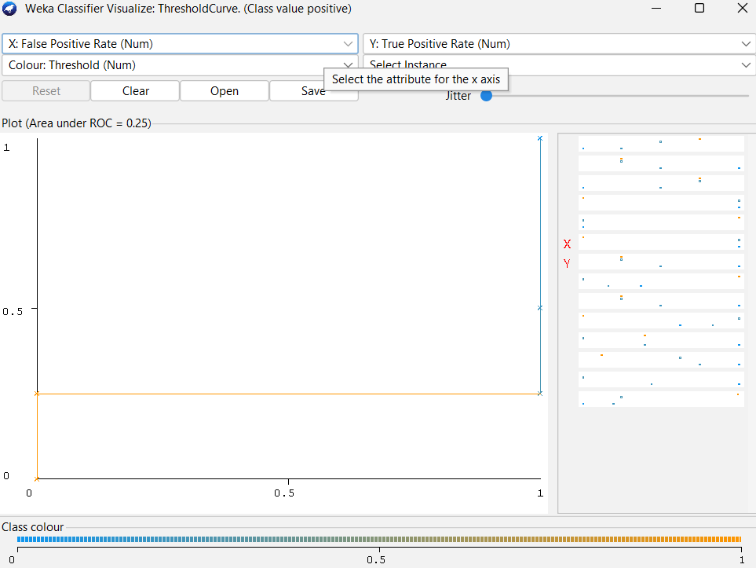

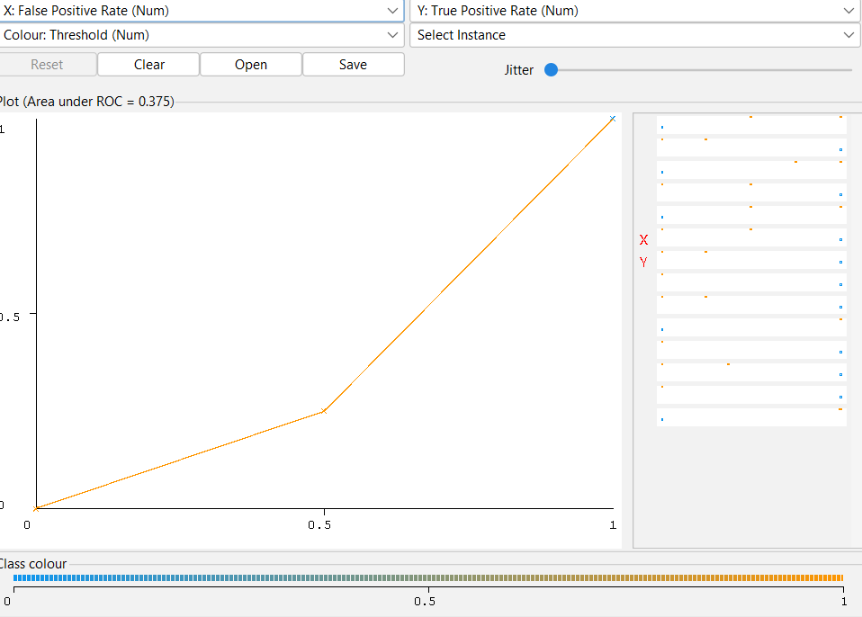

29. Let us consider marks scored by a student in his model exam that has been sorted as follows: 55, 60, 71, 63, 55, 65, 50, 55,58,59,61,63,65,67,71, 72,75. Partition them into three bins by each of the following methods. Plot the data points using histogram in R.
(a) equal-frequency (equi-depth) partitioning
(b) equal-width partitioning
(c) clustering

CODE :
marks <- c(55,60,71,63,55,65,50,55,58,59,61,63,65,67,71,72,75)

bins_eq_freq <- cut(rank(marks), breaks=3, labels=c("Bin1","Bin2","Bin3"))
data.frame(marks, bins_eq_freq)

bins_eq_width <- cut(marks, breaks=3)
data.frame(marks, bins_eq_width)

set.seed(1)
clusters <- kmeans(marks, centers=3)
data.frame(marks, cluster=clusters$cluster)

hist(marks,
main="Histogram of Student Marks",
xlab="Marks",
ylab="Frequency")

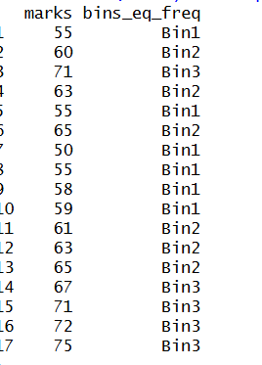
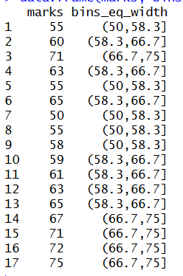
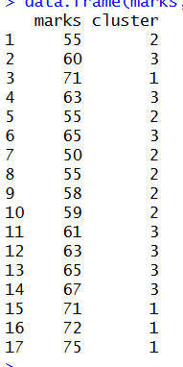
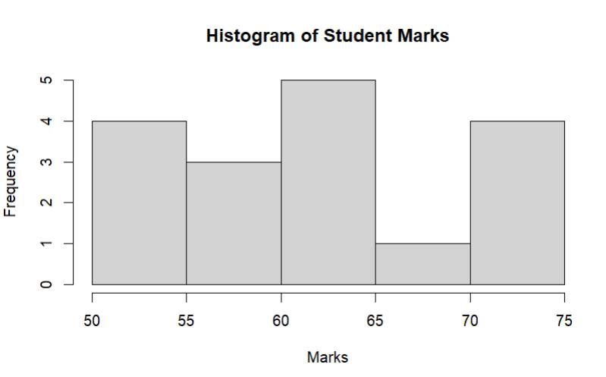

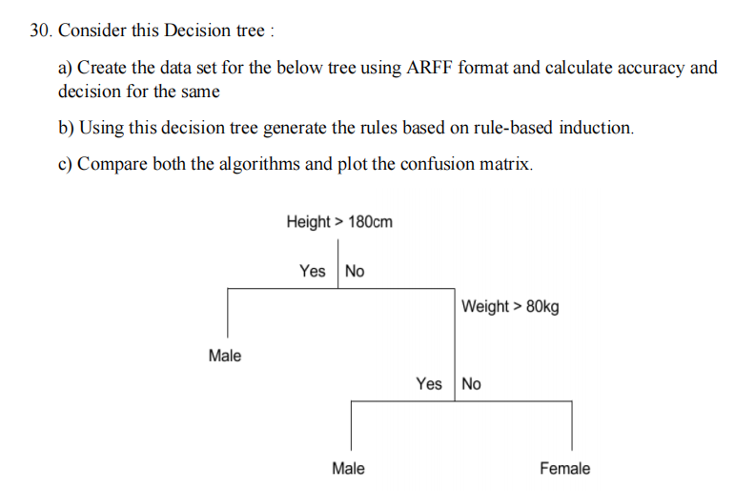
CODE :
@relation gender_classification

@attribute Height numeric
@attribute Weight numeric
@attribute Gender {Male, Female}

@data
181, 70, Male
185, 90, Male
170, 85, Male
175, 75, Female
160, 70, Female
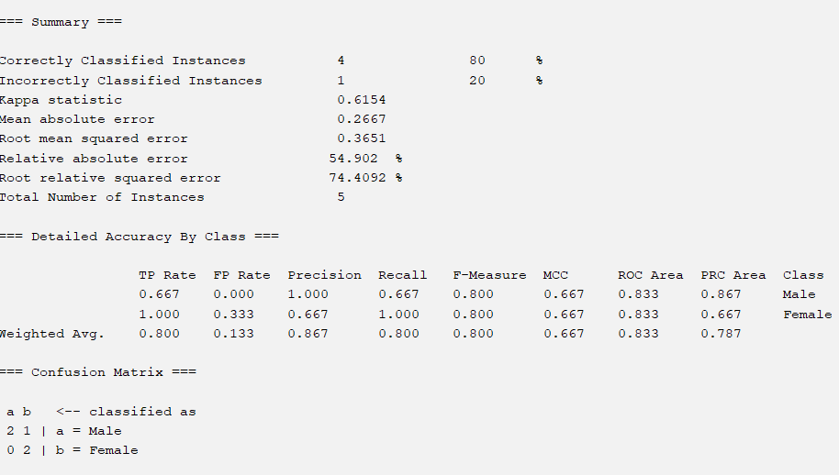
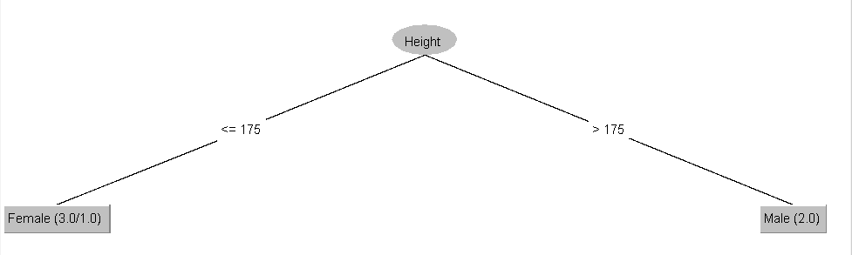

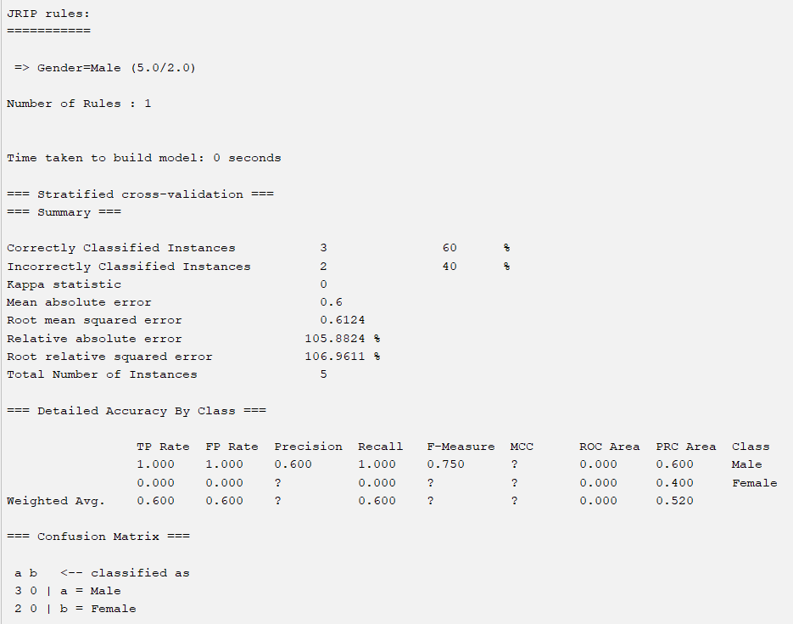
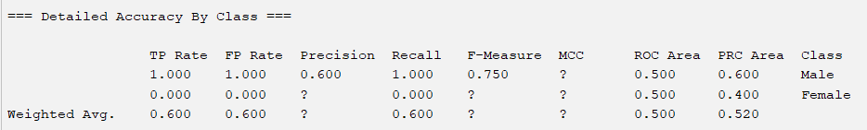

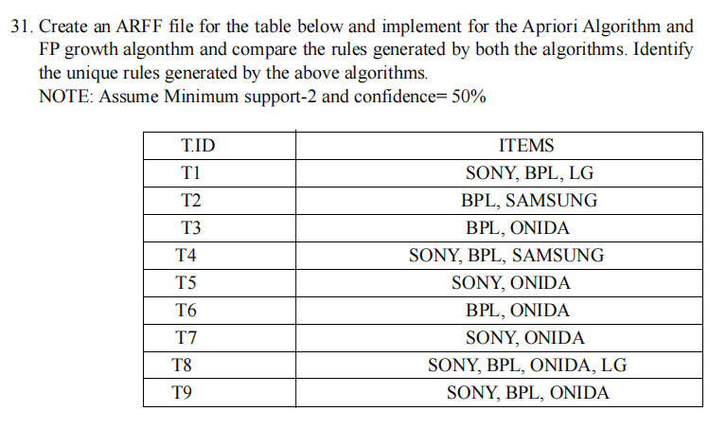

CODE :
@relation electronics

@attribute SONY {t,f}
@attribute BPL {t,f}
@attribute LG {t,f}
@attribute SAMSUNG {t,f}
@attribute ONIDA {t,f}

@data
t,t,t,f,f
f,t,f,t,f
f,t,f,f,t
t,t,f,t,f
t,f,f,f,t
f,t,f,f,t
t,f,f,f,t
t,t,t,f,t
t,t,f,f,t

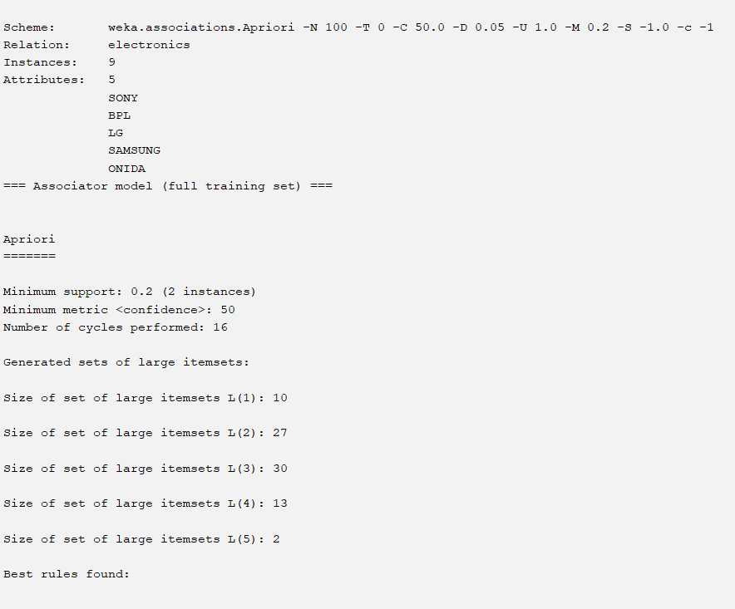
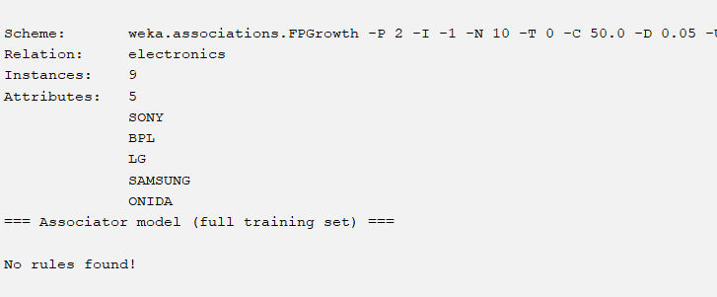

32. The given are the strike-rates scored by a batsman in season 1 in different tournaments.
100, 70, 60, 90, 90. Perform the following in R.
a) Min-Max normalization by setting min = 0 and max = 1
b) z-score normalization
c) z-score normalization using the mean absolute deviation instead of standard deviation
d) normalization by decimal scaling
CODE :

# Data
scores <- c(100, 70, 60, 90, 90)

# Min-Max Normalization (min=0, max=1)
min_val <- min(scores)
max_val <- max(scores)
min_max_norm <- (scores - min_val) / (max_val - min_val)
min_max_norm
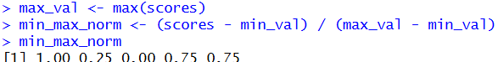

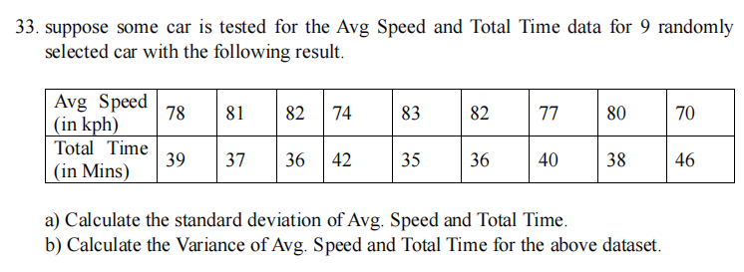

CODE :
avg_speed <- c(78, 81, 82, 74, 83, 82, 77, 80, 70)
total_time <- c(39, 37, 36, 42, 35, 36, 40, 38, 46)

mean(avg_speed) # Mean of Avg Speed
mean(total_time) # Mean of Total Time

sd(avg_speed) # SD of Avg Speed
sd(total_time) # SD of Total Time

var(avg_speed) # Variance of Avg Speed
var(total_time) # Variance of Total Time

results <- data.frame(
Parameter = c("Avg Speed (kph)", "Total Time (min)"),
Mean = c(mean(avg_speed), mean(total_time)),
SD = c(sd(avg_speed), sd(total_time)),
Variance = c(var(avg_speed), var(total_time))
)
print(results)

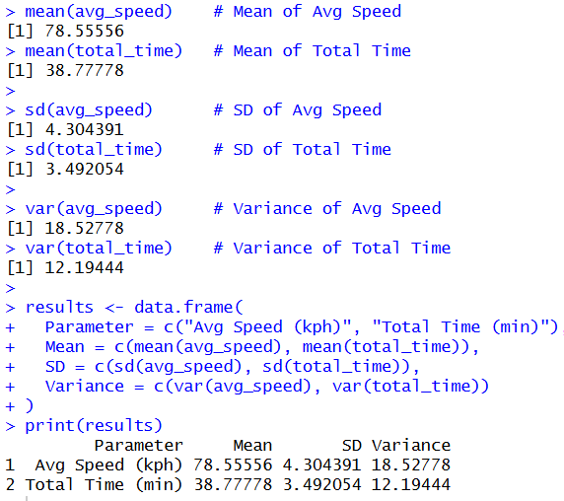

34. Consider a person want to take a census/plot for the breast-cancer affected people through the years. Create a own dataset with this parameters age, tumor size, in v-nodes [example between age 1-5 = no of count, 6-10-no of count, etc]
Draw the Histogram, scatter plot, box plot
CODE :

# Create dataset
data <- data.frame(
Age = c(5, 8, 12, 18, 25, 32, 40, 45, 52, 60, 68, 72),
Tumor_Size = c(1.2, 1.5, 2.0, 2.4, 3.1, 3.5, 4.0, 4.3, 4.8, 5.2, 5.8, 6.1),
V_Nodes = c(0, 1, 1, 2, 2, 3, 4, 4, 5, 6, 6, 7)
)

# --------------------
# Histogram (Age distribution)
# --------------------
hist(data$Age,
col = "lightpink",
main = "Histogram of Age Distribution",
xlab = "Age",
ylab = "Number of Patients")

# --------------------
# Scatter Plot (Tumor Size vs Age)
# --------------------
plot(data$Age, data$Tumor_Size,
col = "blue",
pch = 19,
main = "Scatter Plot of Tumor Size vs Age",
xlab = "Age",
ylab = "Tumor Size (cm)")

# --------------------
# Box Plot (Tumor Size)
# --------------------
boxplot(data$Tumor_Size,
col = "lightgreen",
main = "Box Plot of Tumor Size",
ylab = "Tumor Size (cm)")

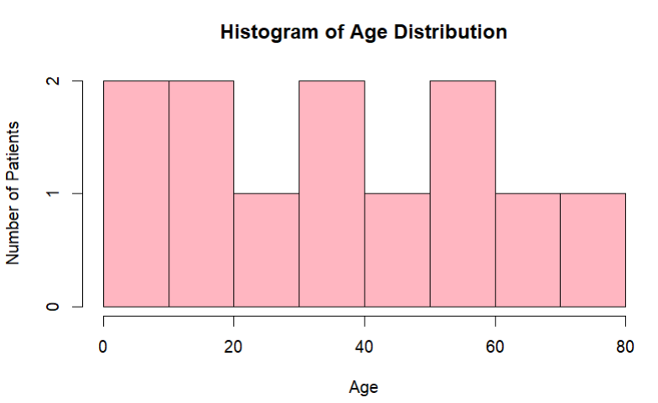
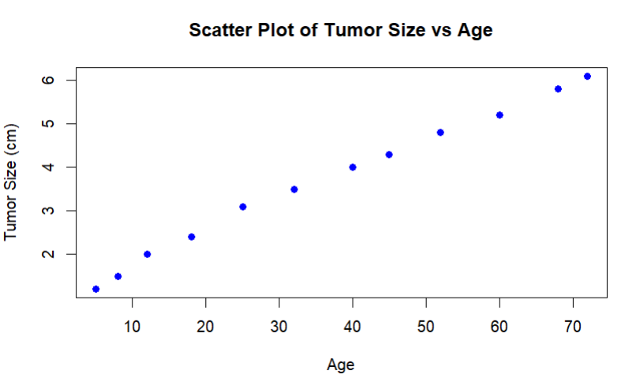
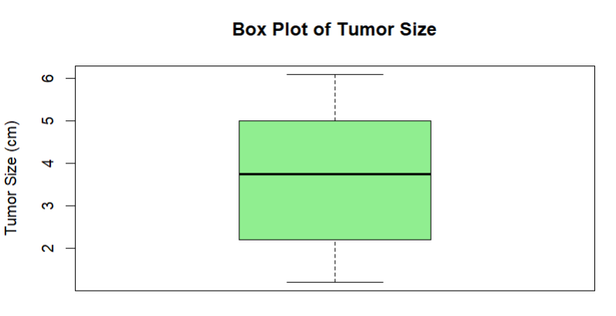

- A shepherd boy gets bored tending the town's flock. To have some fun, he cries out, "Wolf!" even though no wolf is in sight. The villagers run to protect the flock, but then get really mad when they realize the boy was playing a joke on them. One night, the shepherd boy sees a real wolf approaching the flock and calls out, "Wolf!" The villagers refuse to be fooled again and stay in their houses. The hungry wolf turns the flock into lamb chops. The town goves hungry. Panic ensures.

CODE : (CSV)
Event_ID,Actor,Action,Truthful,Villagers_Response,Outcome
1,Boy,Cry,No,Run,Angry
2,Boy,Cry,No,Run,Angry
3,Boy,Cry,Yes,Ignore,Sheep_eaten
4,Wolf,Attack,NA,NA,Sheep_eaten
5,Villagers,Respond,NA,Run,Safe
